**A CRM APPLICATION TO HANDLE CLIENTS AND THEIR PROPERTY RELATED REQUIREMENTS**

# 1. PROJECT OVERVIEW:

This project focuses on creating a **CRM solution in Salesforce** to streamline handling client property-related requirements. Designed to address the challenge of **efficiently managing client and property records**, the project aims to **enhance user experience and data accuracy** by automating data entry and approval processes. Through Salesforce’s capabilities, this CRM solution will support real estate client management, providing a comprehensive approach to client interaction and property management.

The CRM application will leverage modern web technologies to provide a user-friendly, scalable platform that enhances operational efficiency, improves user experience, and ensures data accuracy. This solution aims to support the long-term goals of the organization by enabling better client engagement, streamlined operations, and data-driven decision-making.

# 2. OBJECTIVES:

The objective of this project is to design and develop a comprehensive **Customer Relationship Management (CRM) application** tailored for the real estate industry. The application aims to streamline the management of clients and their property-related requirements, enhancing the efficiency and effectiveness of real estate agents, property managers, and support teams.

**Key goals include:**

1. **Client Management**: Centralize client information, including contact details, preferences, property history, and interactions, to enable personalized and efficient service.
2. **Property Management**: Organize property listings with detailed information, images, pricing, and availability, ensuring quick access for matching with client requirements.
3. **Requirement Tracking**: Capture and track specific client needs (e.g., property type, budget, location) and automatically match them with available properties.
4. **Communication & Engagement**: Facilitate seamless communication with clients through integrated channels (email, SMS, in-app chat) and automated follow-ups.
5. **Task & Appointment Scheduling**: Provide tools for scheduling property visits, follow-ups, and task reminders to improve workflow efficiency.
6. **Analytics & Reporting**: Deliver insights through dashboards and reports to help decision-makers identify trends, monitor sales pipelines, and evaluate performance.
7. **Mobile Accessibility**: Ensure the CRM application is mobile-friendly, enabling agents to access critical information and update records on the go.
8. **Scalability & Customization**: Offer a scalable and customizable platform to adapt to the evolving needs of the business and clients.

By achieving these objectives, the CRM application will empower real estate professionals to deliver superior service, strengthen client relationships, and drive business growth.

**Business Goals**:

1. **Optimize Client Relationship Management:**  
   Streamline and centralize client interactions, ensuring that all communication, preferences, and history are easily accessible to provide a personalized experience.
2. **Improve Sales Conversion Rates:**  
   Leverage automated property matching, lead scoring, and follow-up reminders to increase the likelihood of closing deals faster and with higher success rates.
3. **Enhance Operational Efficiency:**  
   Reduce manual administrative tasks by automating workflows, such as appointment scheduling, document management, and reporting, freeing up time for value-added activities.
4. **Increase Client Retention and Loyalty:**  
   Build stronger relationships with clients by offering proactive support, personalized recommendations, and timely follow-ups, leading to long-term customer satisfaction and loyalty.
5. **Enable Data-Driven Decision-Making:**  
   Provide real-time analytics and insights to help decision-makers understand market trends, agent performance, and business opportunities, driving informed strategies.
6. **Expand Property Reach:**  
   Support efficient property listing and management to showcase inventory to a broader audience and attract more potential clients.
7. **Boost Revenue Growth:**  
   Accelerate the sales cycle, reduce operational costs, and improve service quality to enhance profitability and support business expansion.
8. **Adapt to Market Changes:**  
   Ensure scalability and flexibility in the CRM system to adapt to evolving client needs, market dynamics, and business objectives.

By achieving these goals, the CRM application will enable real estate businesses to operate more effectively, deliver superior customer experiences, and achieve sustainable growth in a competitive market.

**SPECIFIC OUTCOMES:**

**Key Deliverables:**

1. **Client Management Module:**
   * Centralized database for client profiles, including contact details, preferences, and interaction history.
   * Tools for tracking client inquiries and follow-ups.
2. **Property Management Module:**
   * Comprehensive property listing system with details like location, price, availability, images, and features.
   * Search and filter options for matching properties to client requirements.
3. **Lead and Requirement Tracking:**
   * Capture and manage leads with tools to track their progress through the sales funnel.
   * Match client requirements with available properties automatically.
4. **Communication Tools:**
   * Integrated email, SMS, and in-app messaging for seamless communication.
   * Automated reminders and follow-up notifications.
5. **Task and Schedule Management:**
   * Calendar integration for scheduling property viewings and client meetings.
   * Task assignment and progress tracking for team members.
6. **Analytics and Reporting:**
   * Real-time dashboards for monitoring sales performance, client engagement, and property availability.
   * Customizable reports on lead conversion rates, agent productivity, and business trends.
7. **Mobile and Web Accessibility:**
   * Mobile-responsive CRM platform for on-the-go access.
   * Dedicated mobile app for agents and managers.
8. **Integration Capabilities:**
   * Integration with third-party tools like email services, document signing platforms, and payment gateways.
9. **Security and Compliance:**
   * Robust data protection measures to safeguard client and property information.
   * Adherence to legal and regulatory requirements, such as GDPR or data privacy laws.
10. **Customizable User Interface:**
    * Intuitive design with user-friendly navigation tailored to the real estate industry.
    * Configurable features to adapt to business-specific workflows.

**Specific Outcomes:**

1. **Improved Client Satisfaction:**  
   Deliver personalized and timely service that fosters trust and loyalty.
2. **Increased Sales Efficiency:**  
   Reduce the time taken to close deals with automated lead and property matching.
3. **Enhanced Team Productivity:**  
   Enable agents and managers to focus on core activities by automating repetitive tasks.
4. **Higher Conversion Rates:**  
   Optimize lead management and follow-ups, improving the conversion of inquiries into successful deals.
5. **Better Decision-Making:**  
   Utilize data-driven insights to identify opportunities, address bottlenecks, and strategize effectively.
6. **Scalable Growth:**  
   Support expanding client bases and property portfolios without compromising efficiency or quality.
7. **Cost Savings:**  
   Minimize manual errors and administrative costs through automation and streamlined processes.
8. **Competitive Advantage:**  
   Establish the business as a tech-savvy, client-focused leader in the real estate industry.

By delivering these outcomes and functionalities, the CRM application will position the business for success in a competitive market while meeting client and operational needs effectively.

# 3. SALESFORCE KEY FEATURES AND CONCEPTS UTILIZED:

**Jotform Integration**: Automatically creates customer records in Salesforce.

**Custom Objects**: Property details and client information managed within custom Salesforce objects.

**Approval Process**: Automated process for approving property records.

**Record Trigger Flow**: Automates the submission of property records into the approval workflow.

**Lightning Web Component (LWC)**: Custom component for property details, embedded in the App Page.

**Apex Classes**: Programmatic control over business logic, secured through profile access.

# 4. DETAILED STEPS TO SOLUTION DESIGN:

**Data Model**:

Custom objects: Client and Property with fields for contact information, property details, and approval status.

**User Interface**:

Created App Page for property management.

LWC to display and manage property details, accessible on the App Page.

Integrated Jotform on the client website to feed data directly into Salesforce.

System Architecture Design:

Objective: Define the high-level architecture of the CRM application.

**Business Logic**:

Apex triggers for automation and error-checking.

Record trigger flow to initiate the property approval process automatically.

**Development Plan:**

*Objective:* Break down the project into manageable tasks.

Example code:

<template>

  <lightning-card>

    <div class="slds-box">

      <div class="slds-text-align_left">

        <h1 style="font-size: 20px;"><b>Properties</b></h1>

      </div>

      <div>

        <div class="slds-grid slds-gutters">

          <div class="slds-col slds-size_5-of-6">

            <lightning-combobox name="Type" label="Property Type" value={typevar} placeholder="Select Property type"

              options={propetyoptions} onchange={changehandler}></lightning-combobox>

          </div>

          <div class="slds-col slds-size_1-of-6">

            <br>

            <lightning-button-icon variant="neutral" icon-name="standard:search" alternative-text="Search"

            label="Search" onclick={handleClick}></lightning-button-icon>

          </div>

        </div>

      </div>

 </div>

<template if:true={istrue}>

      <div class="slds-box">

        <lightning-datatable key-field="id" data={propertylist} columns={columns}></lightning-datatable>

      </div>

    </template>

    <template if:false={isfalse}>

      <div class="slds-box">

       <div style="font-size: 15px;"><b>No properties Are Found !!</b></div>

      </div>

    </template>

</lightning-card>

</template>

**Milestone 01 - Creating Developer Org**

❖ Go to developer.salesforce.com

❖ Click on sign up.

❖ On the sign up form, enter the following details

❖ First name & Last name – NIVETHA M

❖ Email –nivethamathi2004@gmail.com

❖ Role – SALESFORCE DEVELOPER

❖ Company – Karpaga Vinayaga College Of Engineering And Technology

❖ Country - India

❖ Postal Code – 603314

❖ Username [–Nive11@dev.comm](mailto:–Nive11@dev.comm) ;Password- niveswe11

After setting password. Then you will redirect to your salesforce setup page.

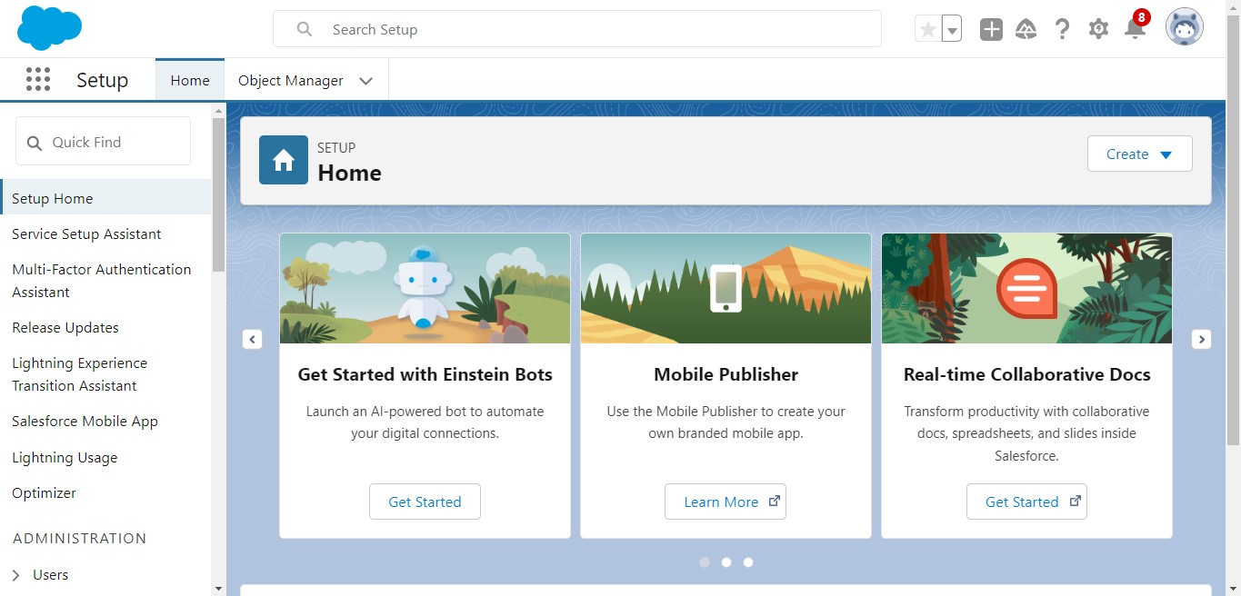

**TASK 1**: Create a Jotform

Create a Jotform and integrate it with the org to create a record of customers automatically

**Objective:** Create a form to capture customer details automatically and create a record in Salesforce.

● **Activity**: a. Develop a JotForm to capture details such as Name, Phone, Email, Address, and the type of property the customer is interested in.

**FORM FILLING AND RECORD SAVING**

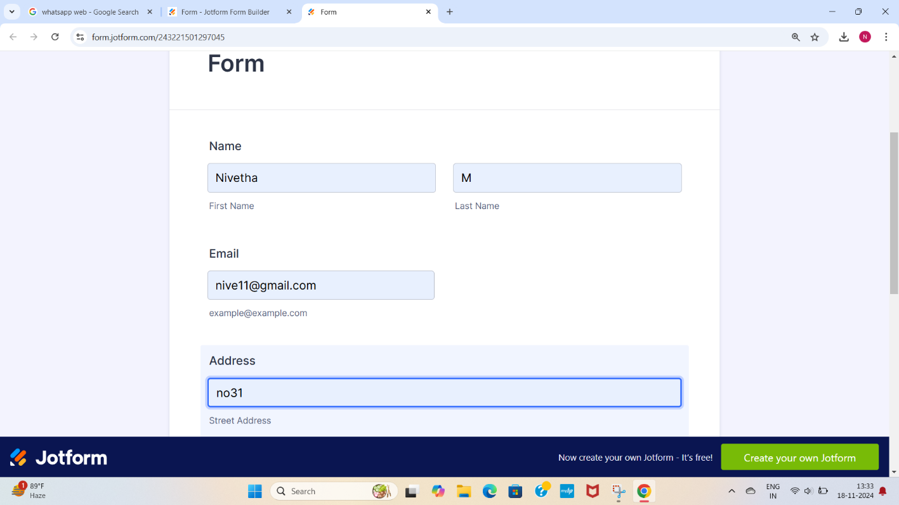

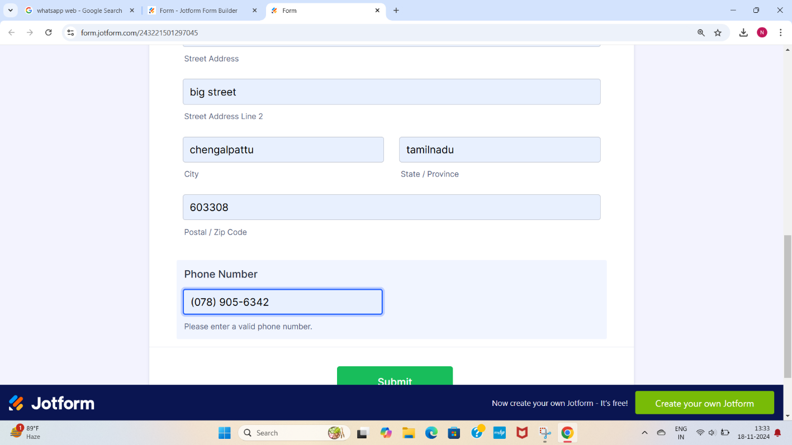

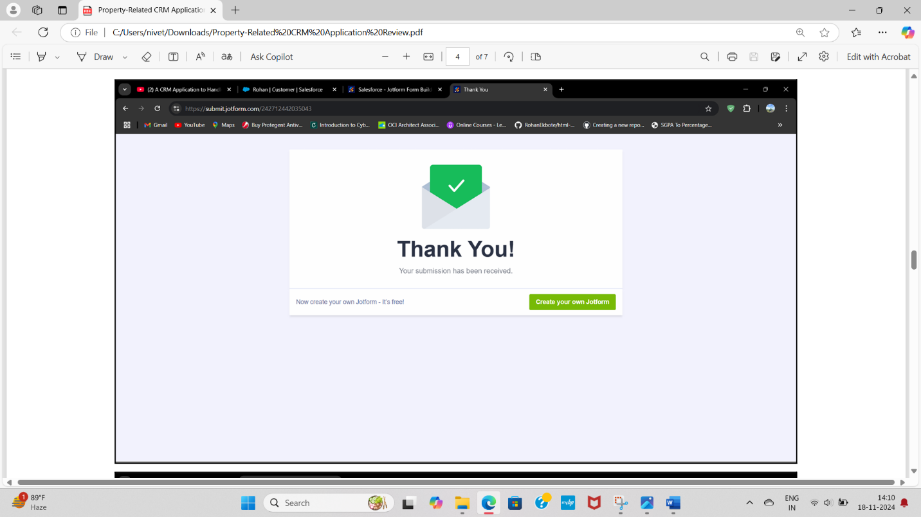

**TASK 2**: Create Objects from Spreadsheet

**Objective:** Directly create objects in Salesforce from a spreadsheet.

● **Activity**: a. Create a Customer object

**Create Customer object**

1. Go to your object manager and and click on create object from spreadsheet.
2. Click on the link to get the spreadsheet
3. [customer](https://docs.google.com/spreadsheets/d/1OnrKr4zVsbXrGvU6r0edgB6XOUlp4eCpfzHMSj8MN78/edit?usp=sharing)
4. After downloading, upload the file, map the fields and upload to create an object.

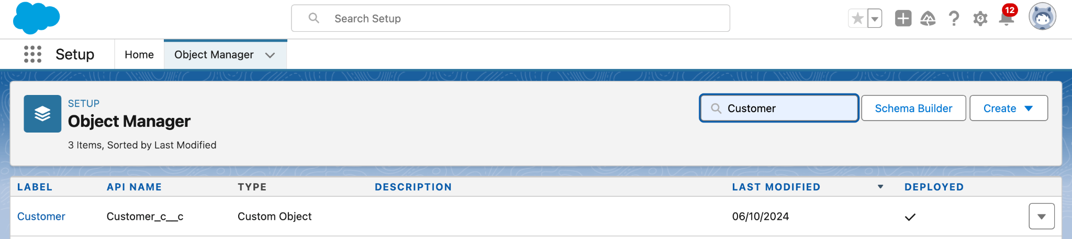

**Create Property object:**

1. Follow the same from the customer object to create the Property Object
2. [Property](https://docs.google.com/spreadsheets/d/1biFjB6xNxRItKb6CT6NHNNujHVVY9DTdXOkN2RL_hbY/edit?usp=sharing)

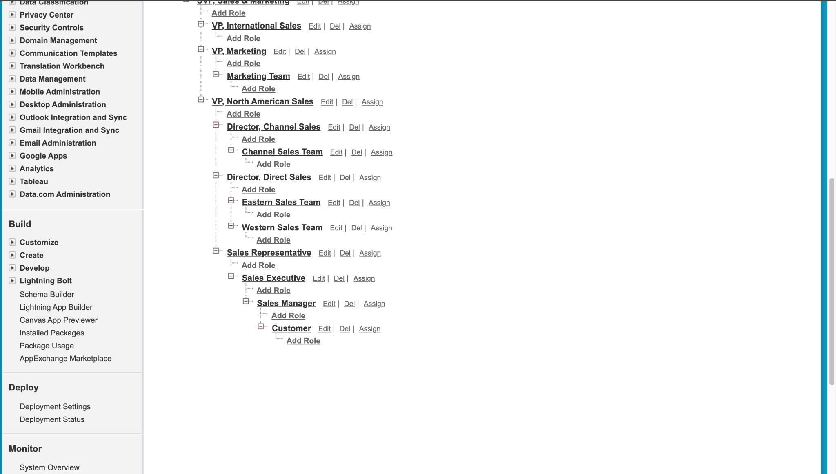

**TASK 3:** Integrate Jotform with Salesforce Platform

In this Milestone we are going to integrate jotform with Salesforce

1. On the Jotform Platform, Click on Integration and choose Salesforce.
2. Click on User Integration and choose “Add to From”.
3. Select the Org with which you want to Integrate your jotform with.
4. Select an Action - Create a record.Select a Salesforce Object : - Customer
5. Map Each and every field on the Object with the fields on the form and “Save Action”.

### **TASK 4:** Create Roles

Create Roles as per business requirenment

Activity: 1

1. Go to Setup and Click on Roles, then click on Expand all and Add a Role just below the Sales Representative
2. Label  - Sales Executive

 Reports to - Sales Representative

* Similarly Create a Role Name “Sales Manager” below Sales Executive which  reports to Sales Executive, Also Add a Role below Sales Manager labeled as “Customer” which reports to Sales Manager.

### **TASK 5**: Create a Property Details App

An App where the objects will be displayed

Activity: 1

1. From Setup>> Go to App Manager and click on New Lightning App and Name it as “Property Details” and add “Customer” and “Property” Object.
2. Click Next >> Next >> Save and Add “System Admin ”Profile

a. Create a new Lightning App named "Property Details" and add Customer and Property objects.

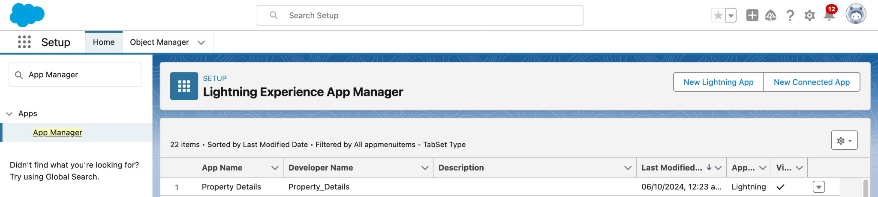

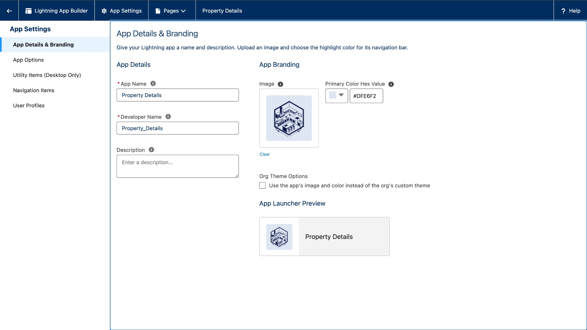

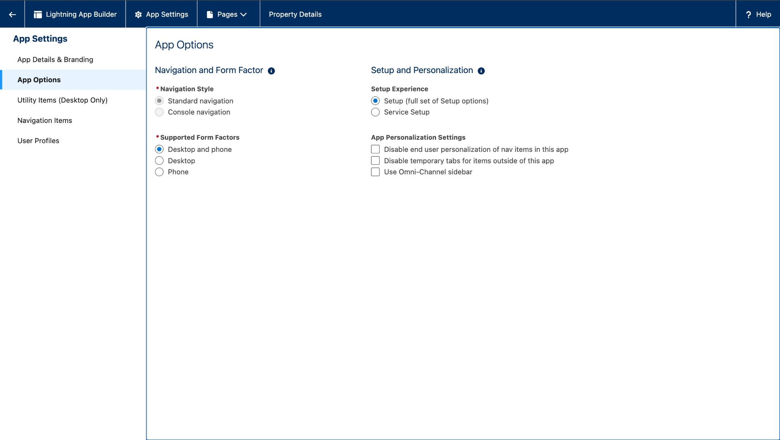

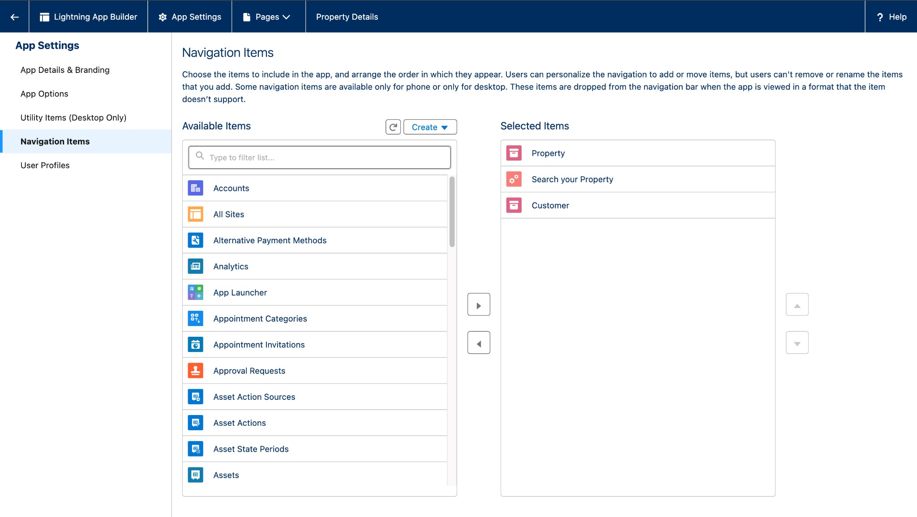

### **TASK 6 :Profiles**

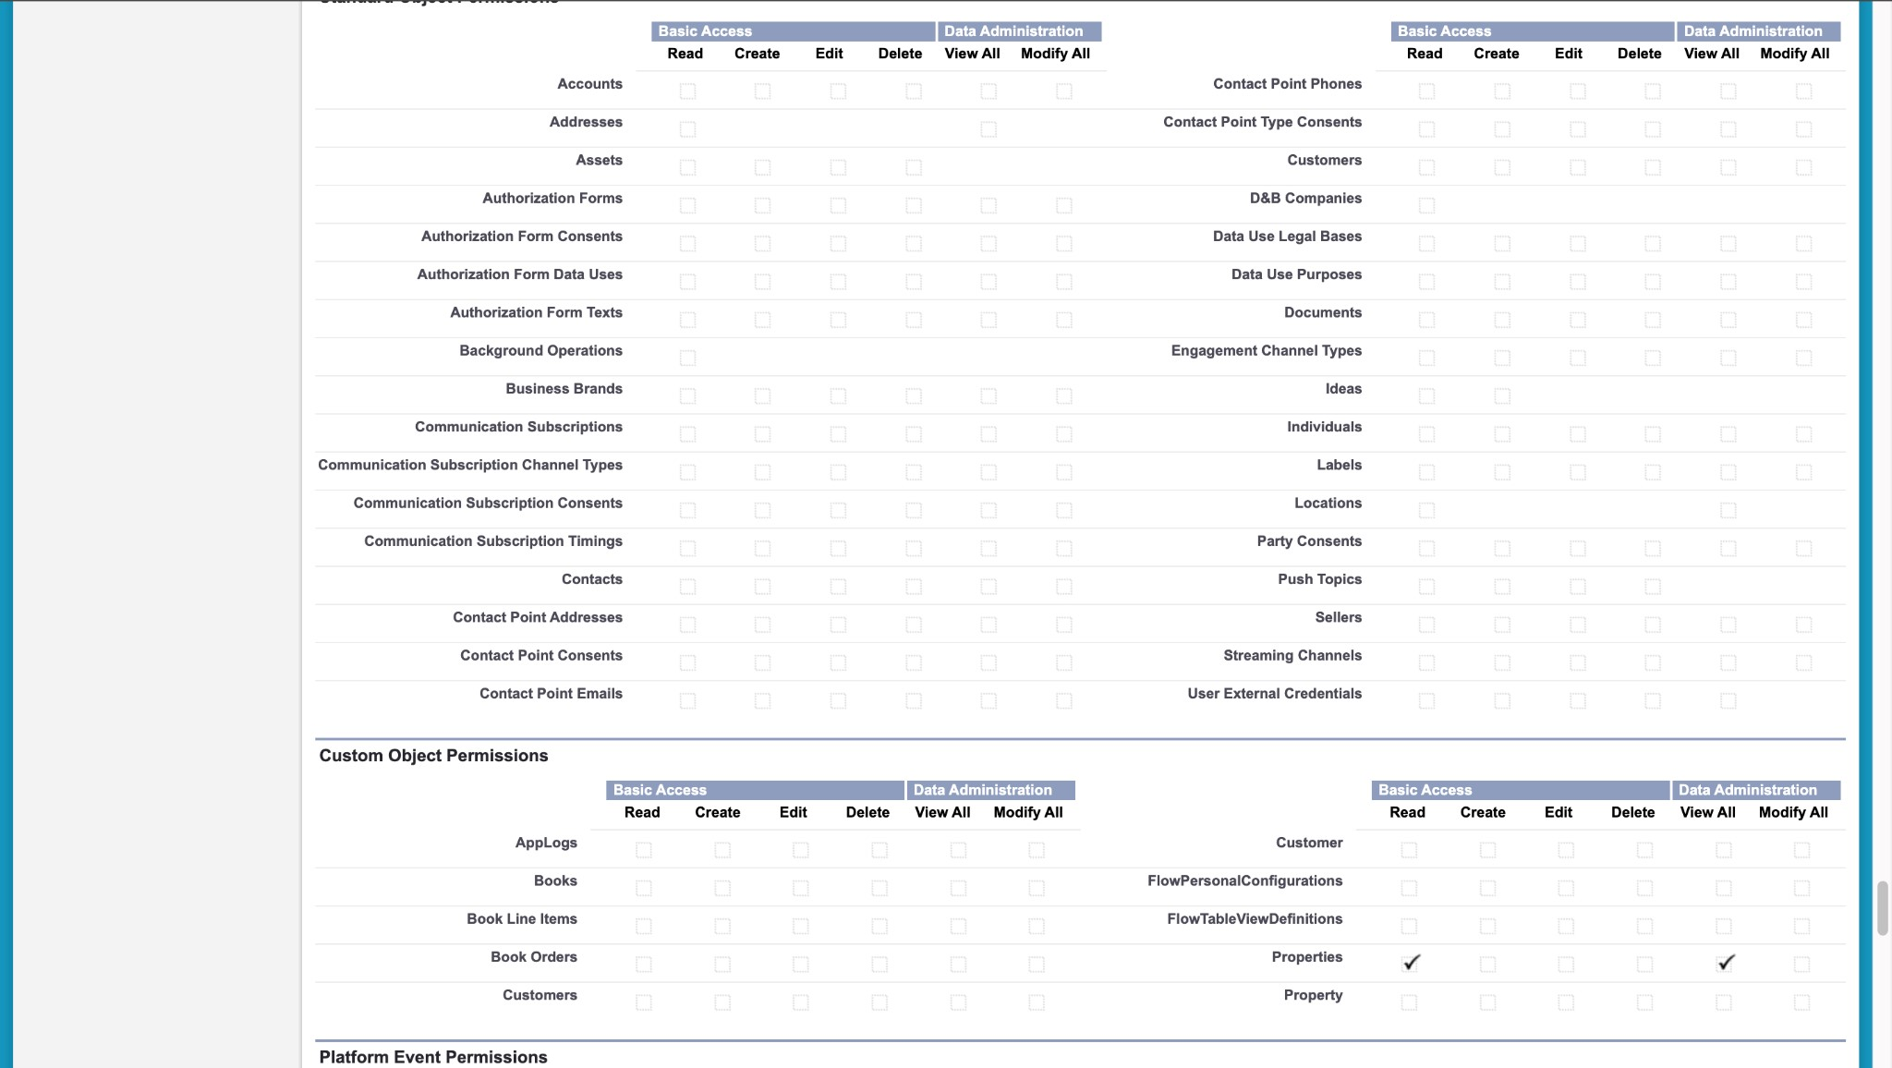Set up profiles as per the business requirements.

1. **Customer Profile**: Clone the Salesforce Platform User profile, name it "Customer," and adjust custom app settings to include only Property Details.

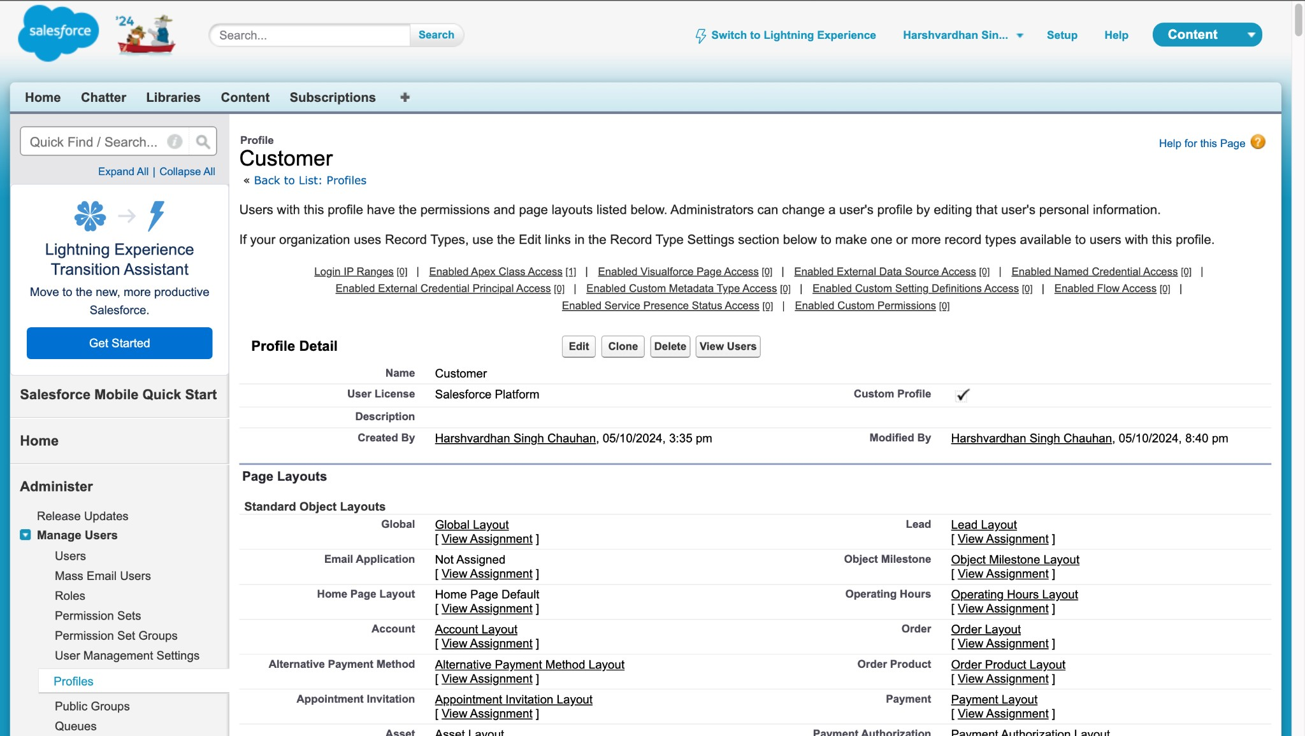

1. **Manager Profile**: Clone the Salesforce Platform User profile, name it

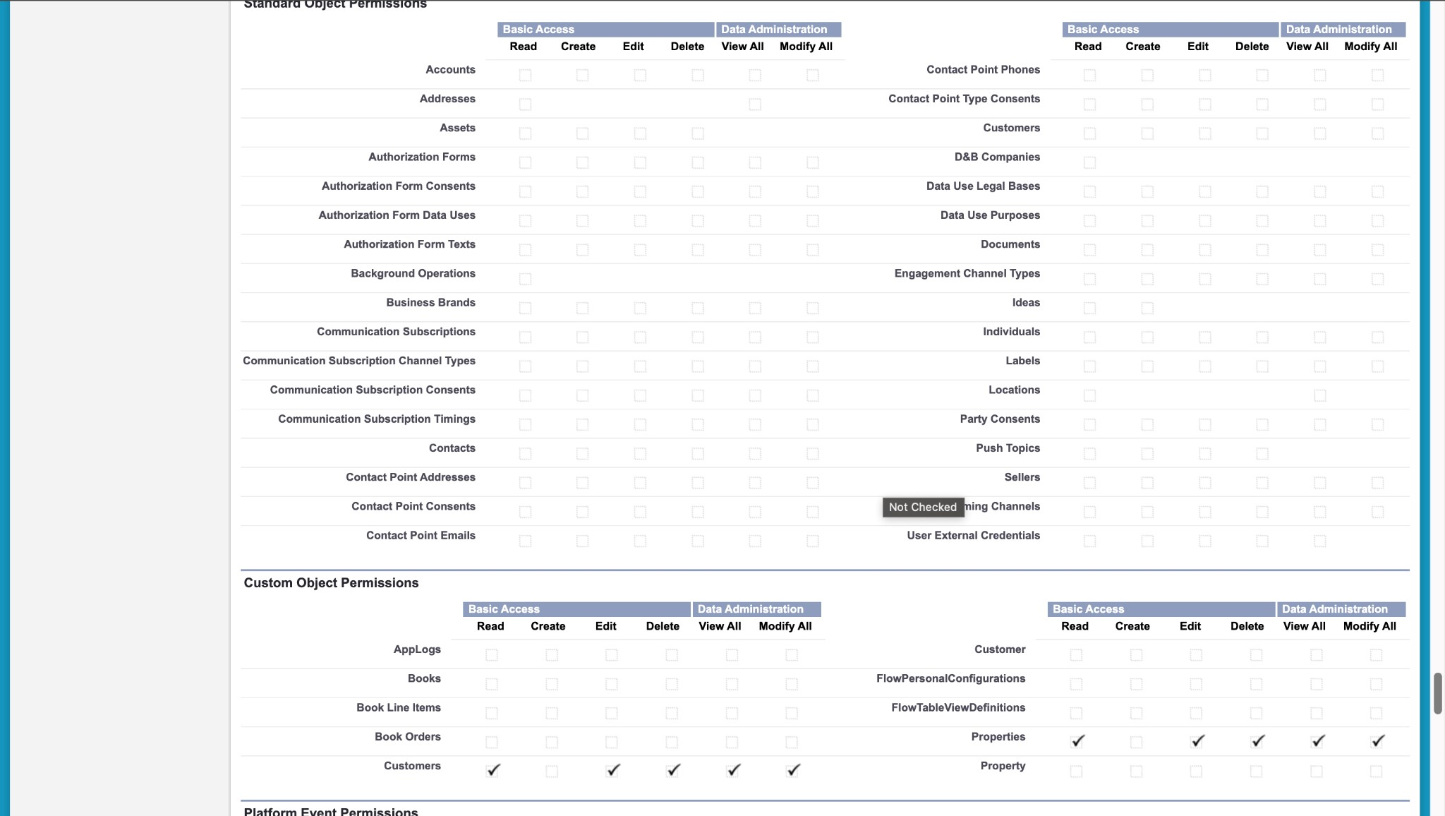"Manager," and enable permissions to modify both Property and Customer records.

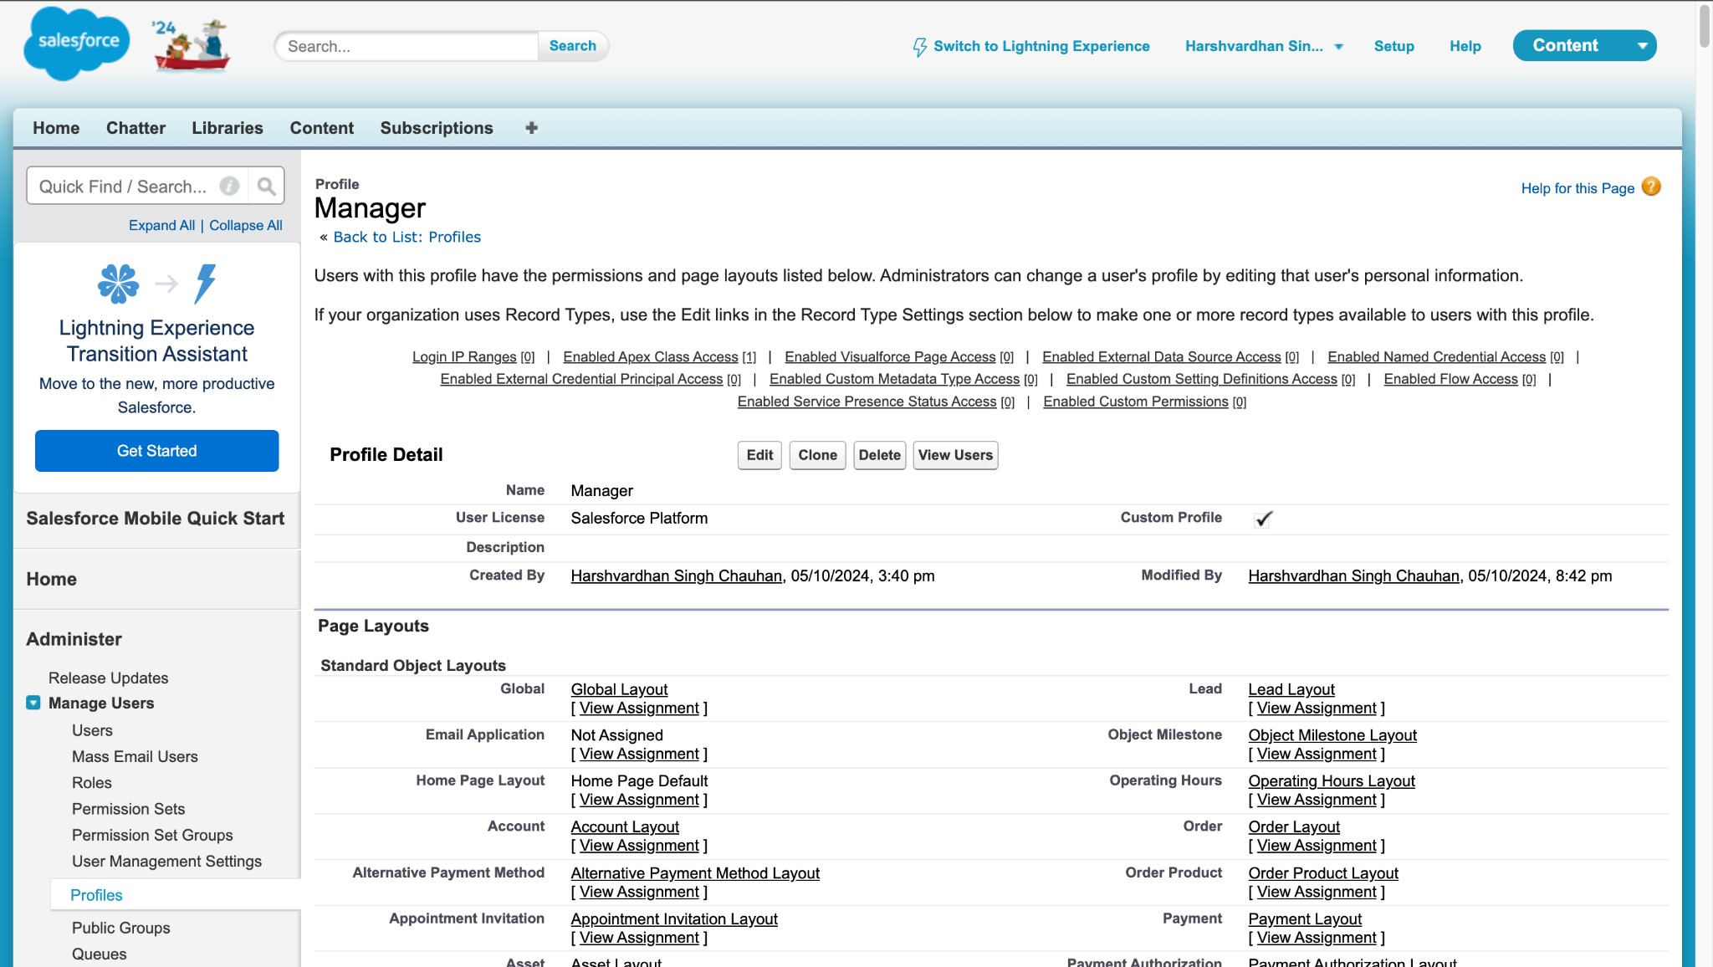

### TASK 7: a Checkbox Field on User

Create a checkbox field on the user object based on business requirements.

a. Create a new field named "Verified" on the User object with the data type "Checkbox."

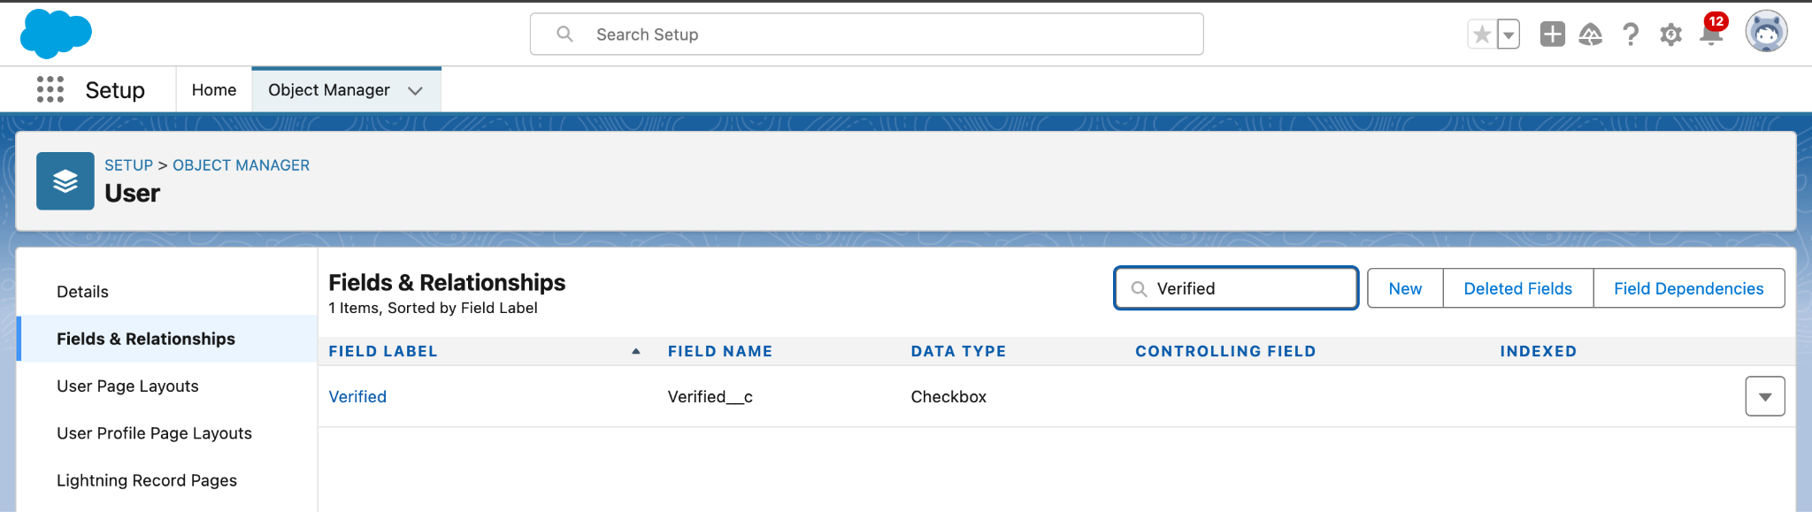

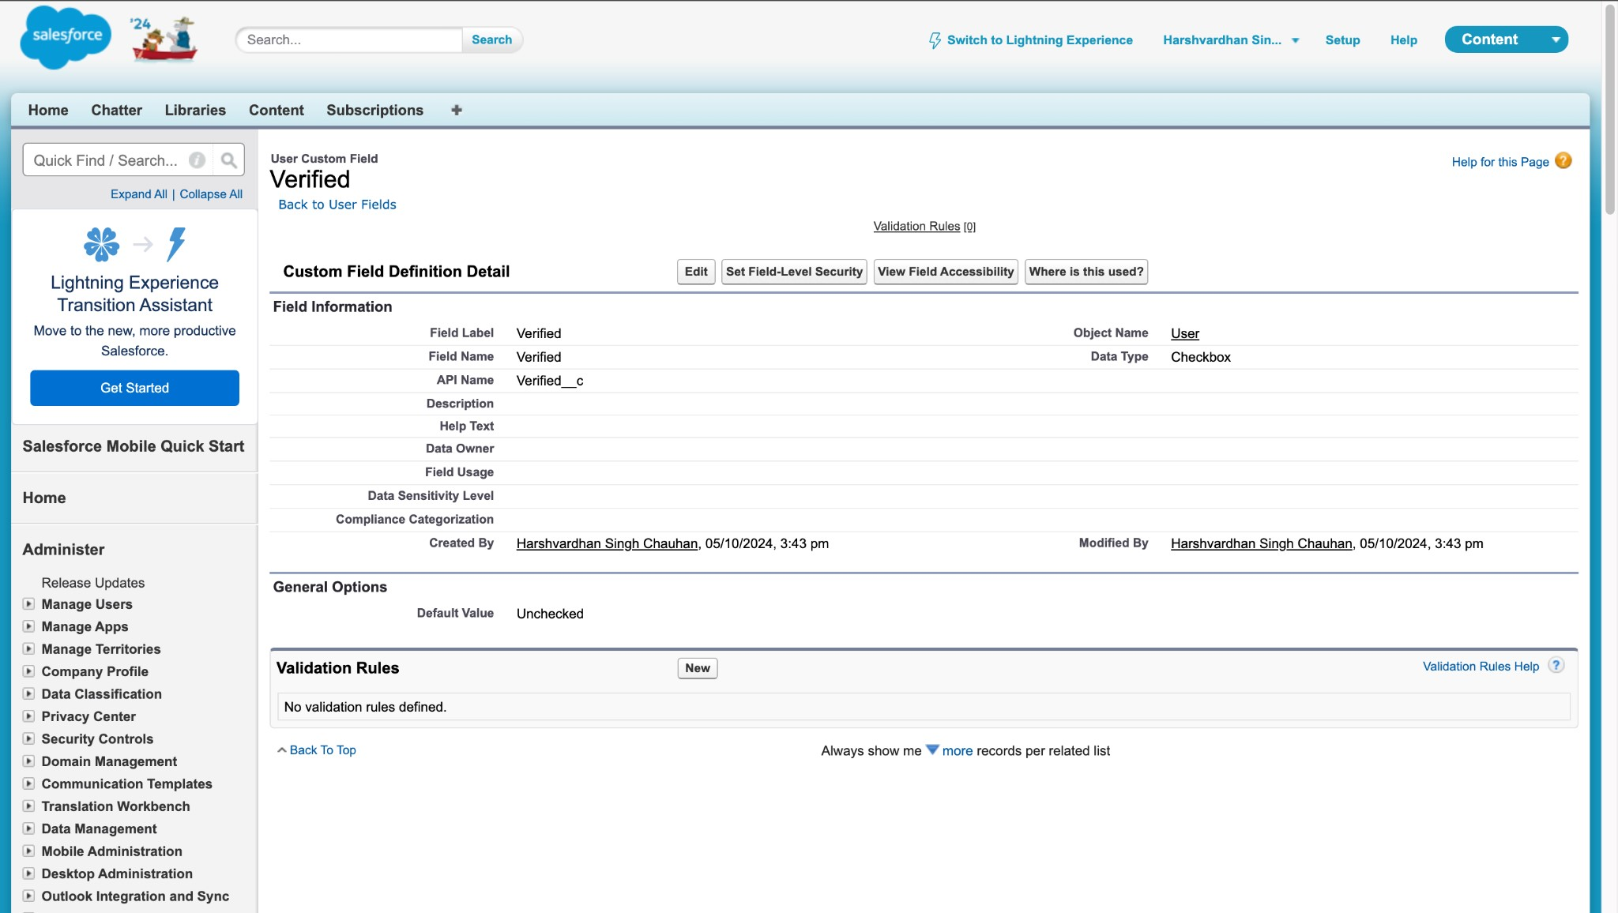

### TASK 8: Create Users

**Objective**: Create users with different roles and profiles.

● **Activity**:

1. 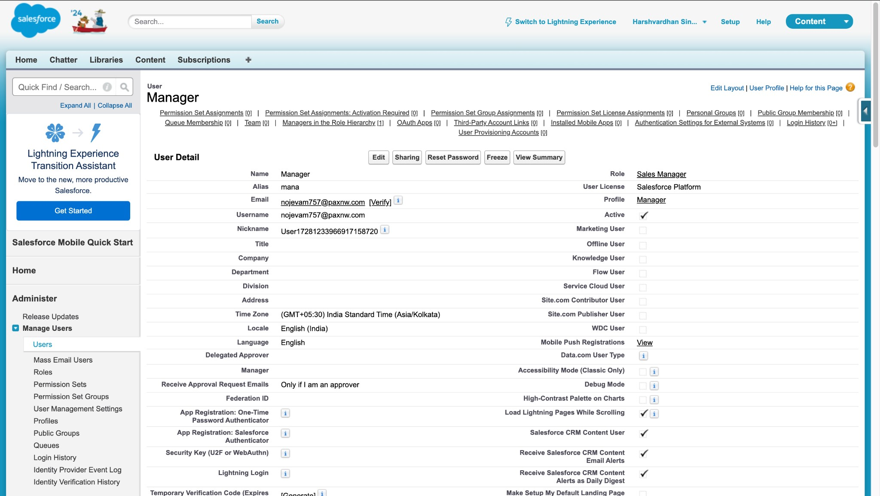**User 1**: Sales Executive with the System Administrator profile.

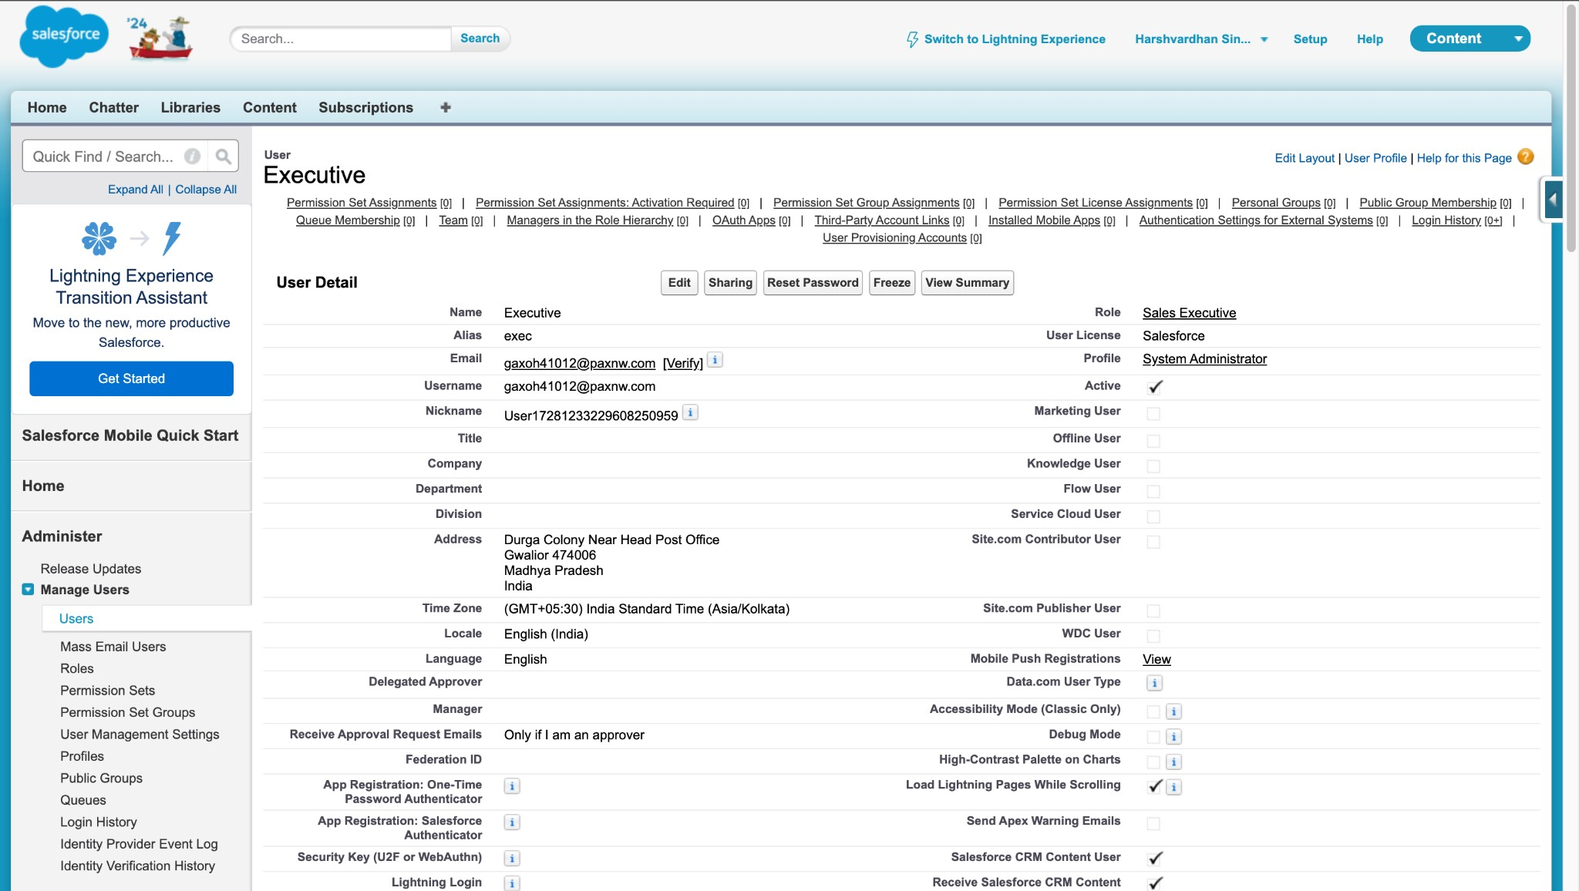

1. **User 2**: Manager with the Manager profile.
2. 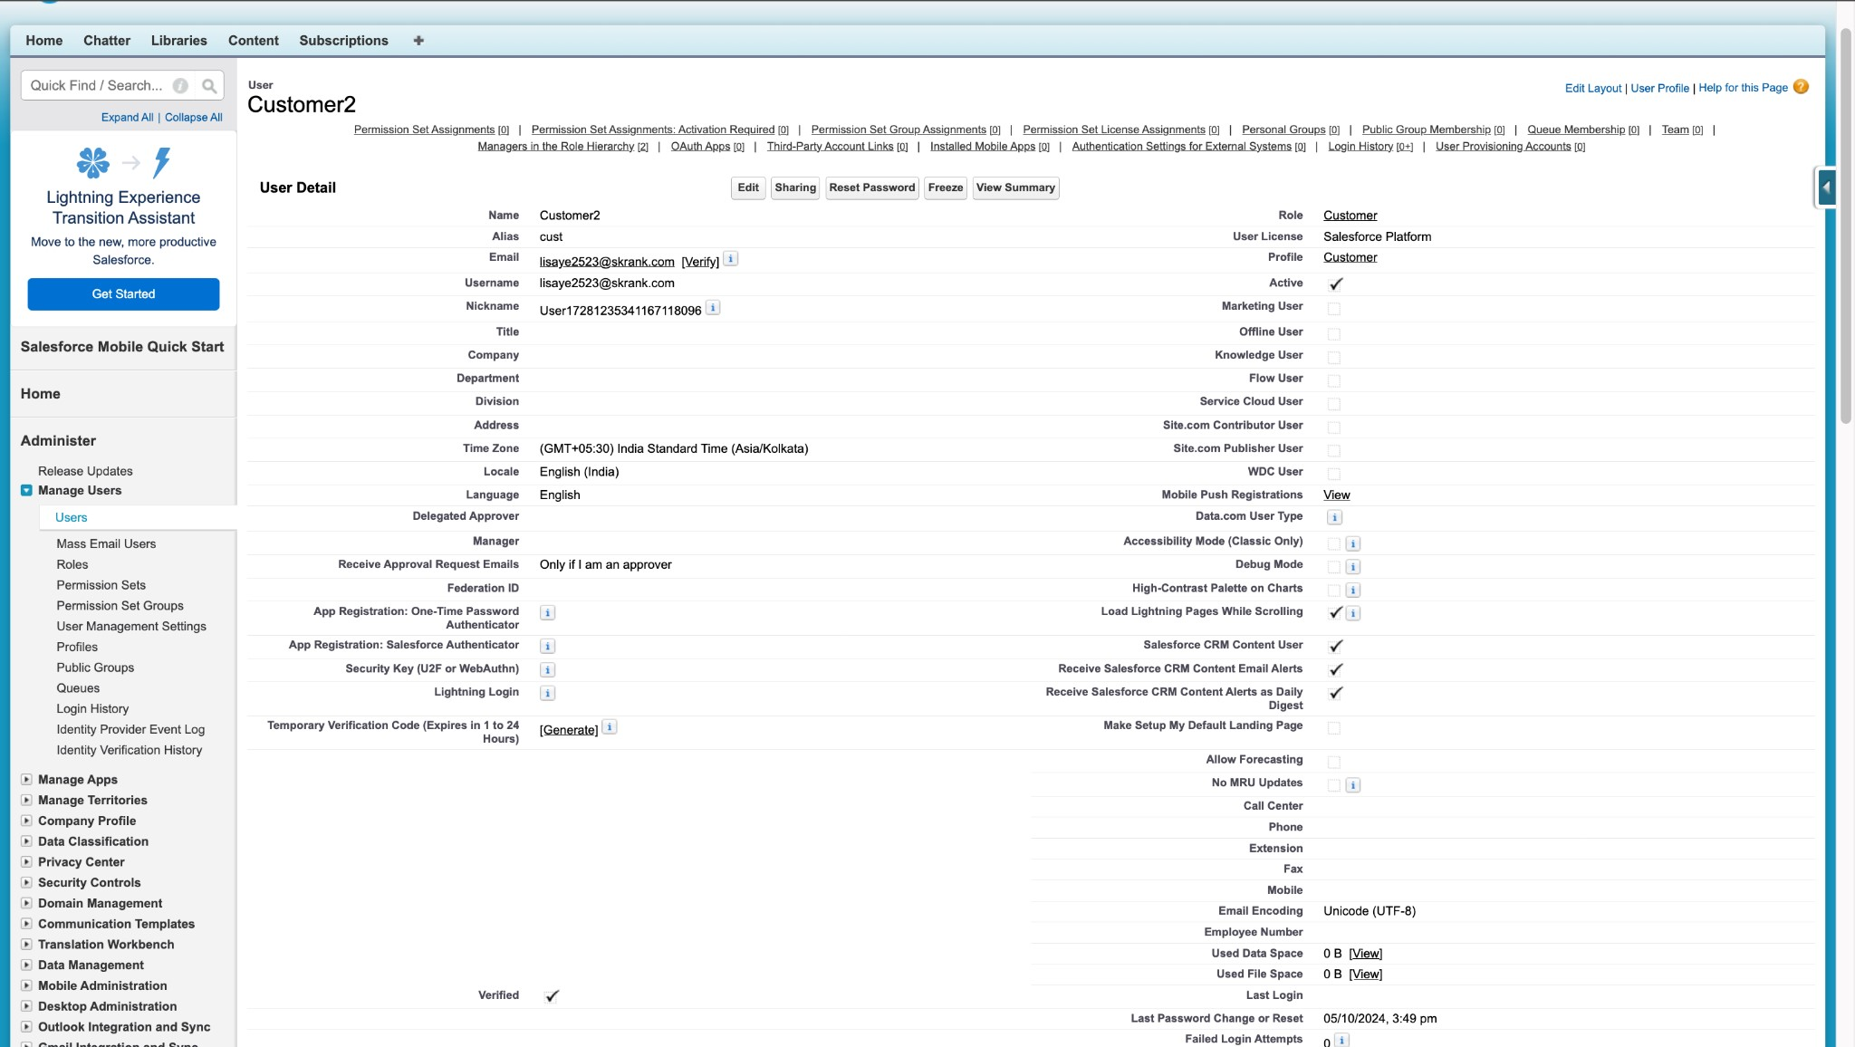**User 3**: Customer with the Customer profile, "Verified" checkbox unchecked.

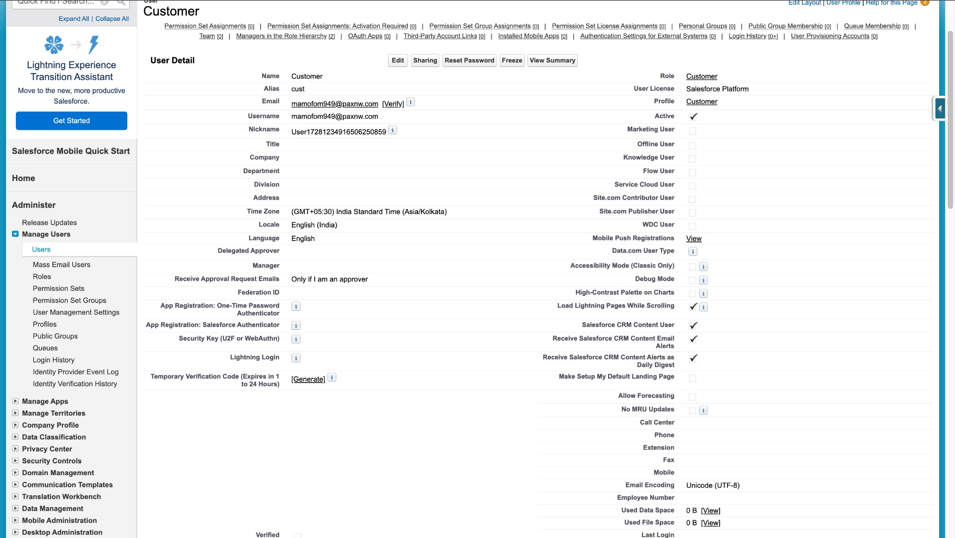

1. **User 4**: Customer2 with the Customer profile, "Verified" checkbox checked.

### TASK 9: Create an Approval Process for the Property Object

**Objective**: Establish an approval process for the Property object.

● **Activity**:

a. Create a "Property Approval" process with criteria such as "Location is not blank" and "Verified equals false." Assign Managers and Sales Executives as approvers, and update the Verified status based on approval outcomes.

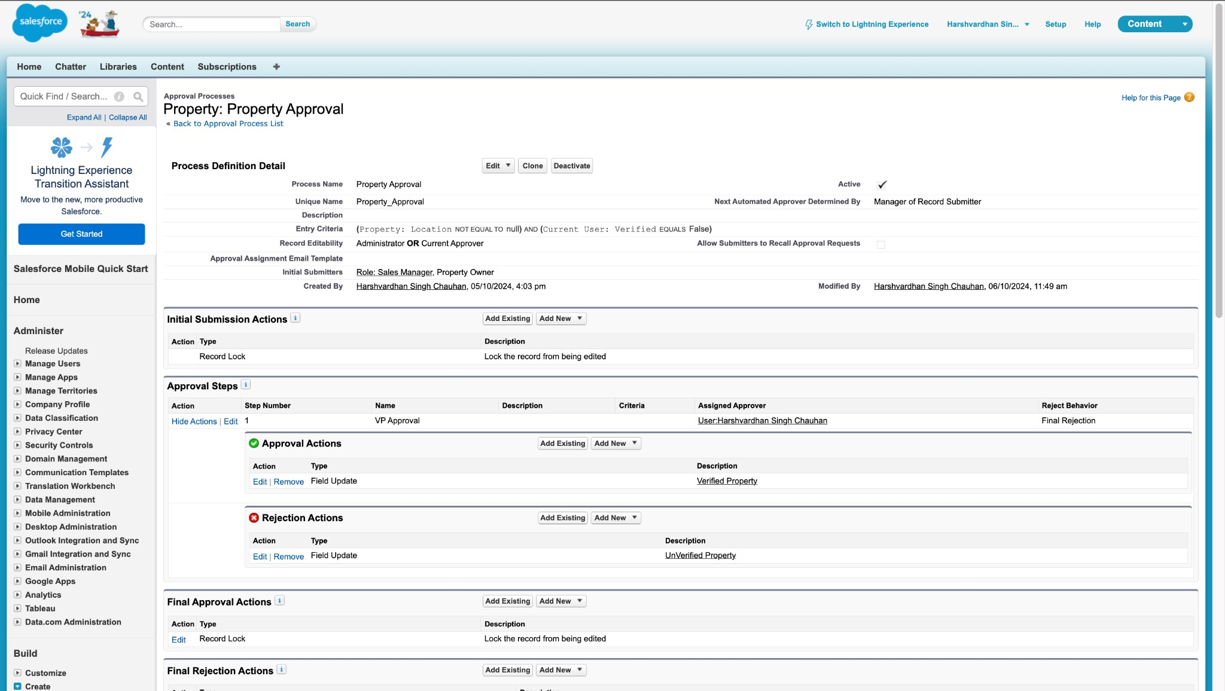

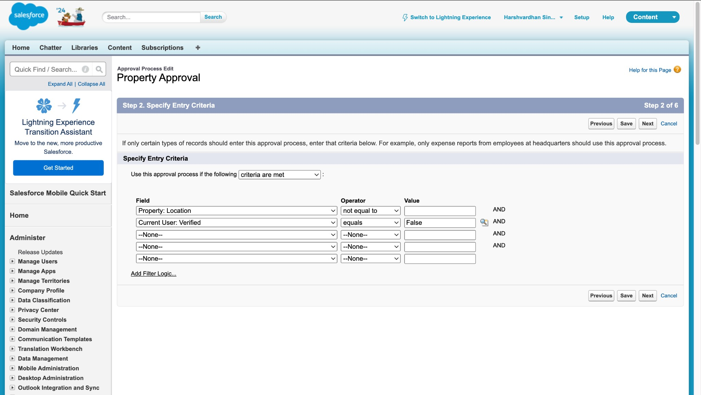

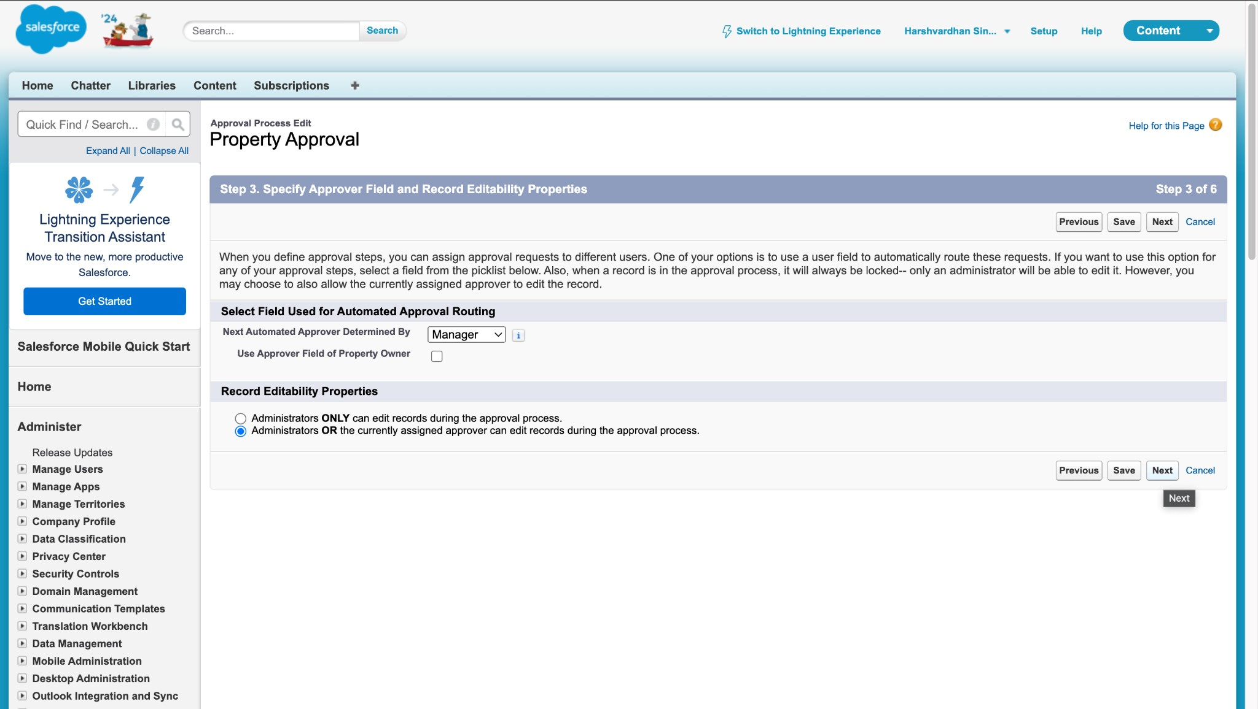

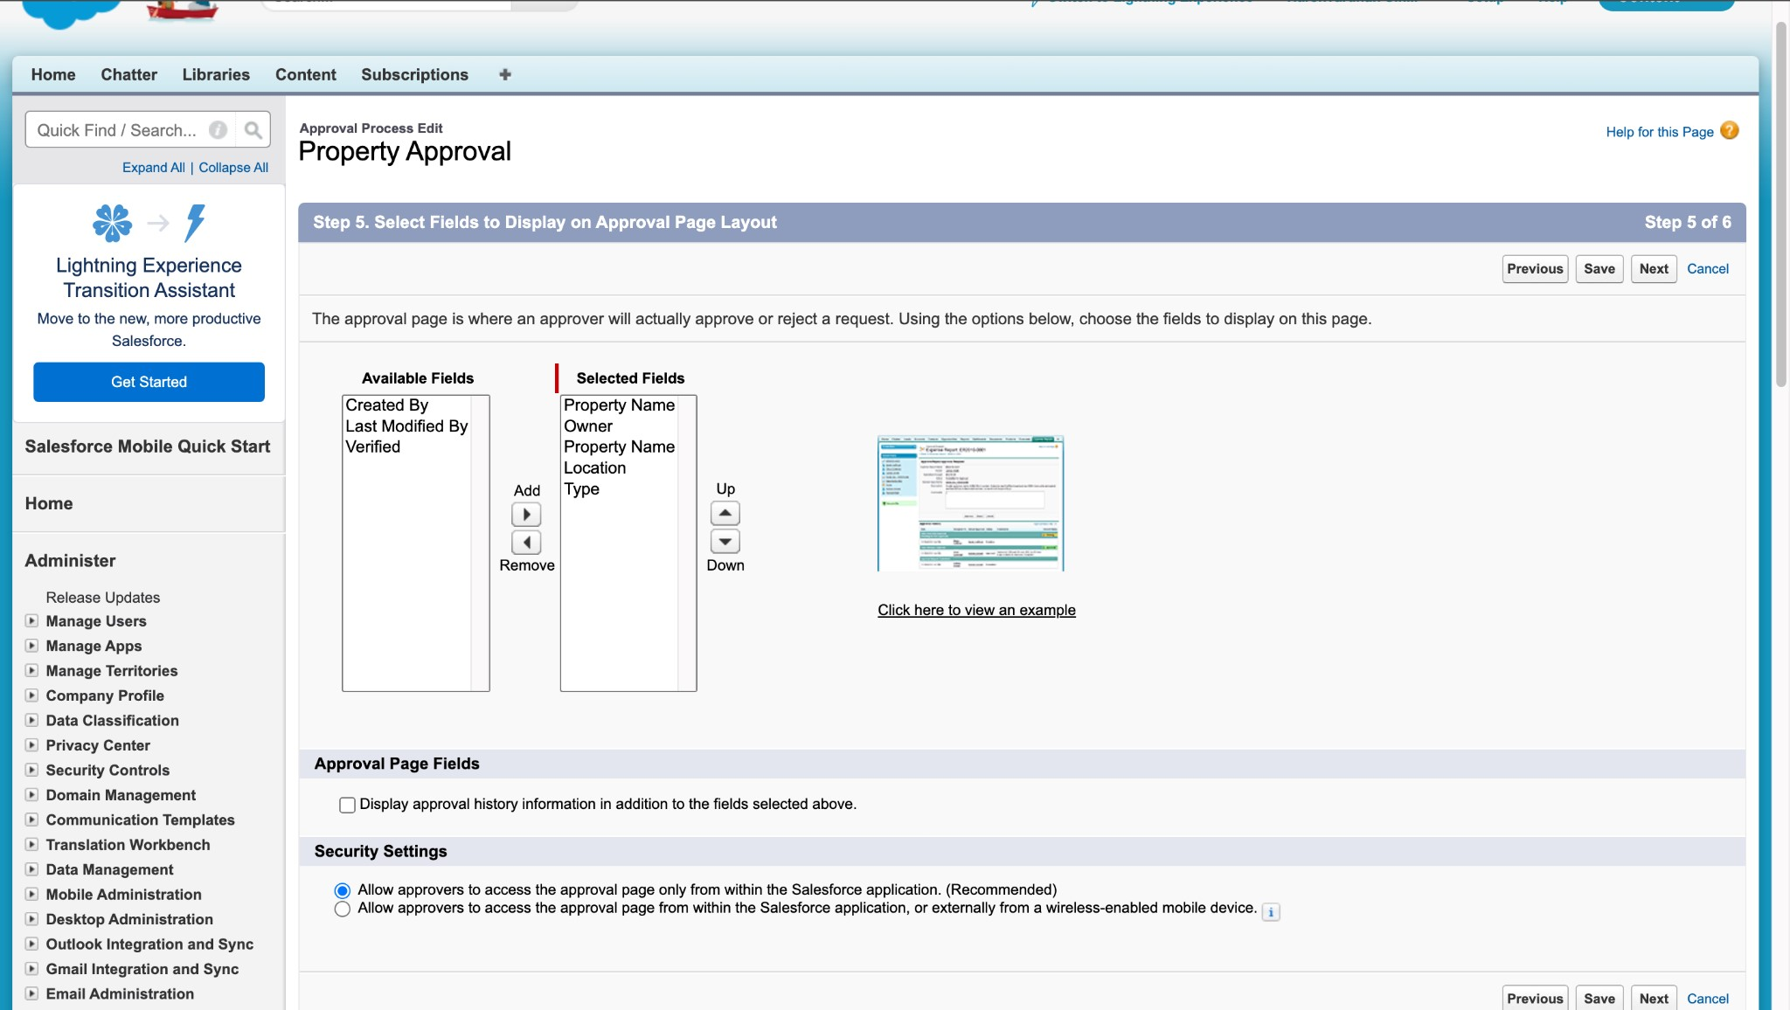

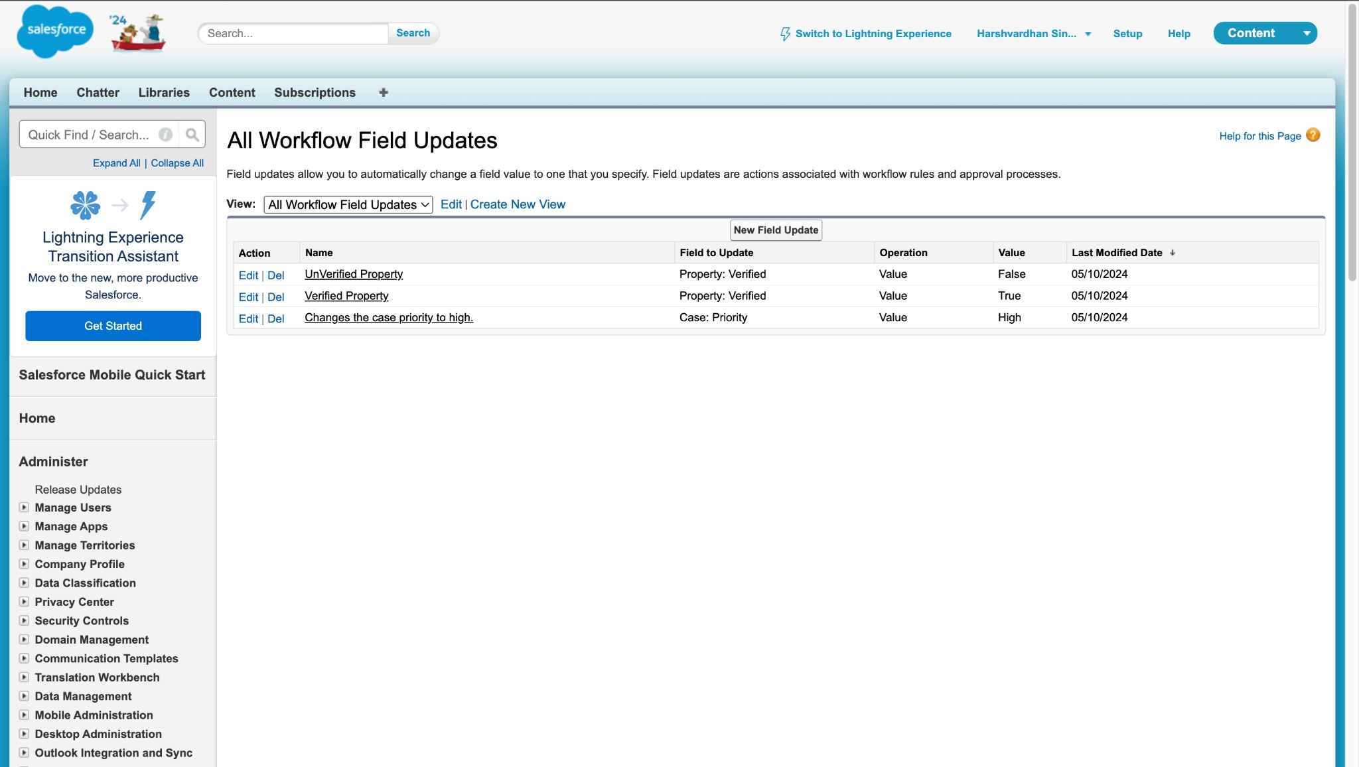

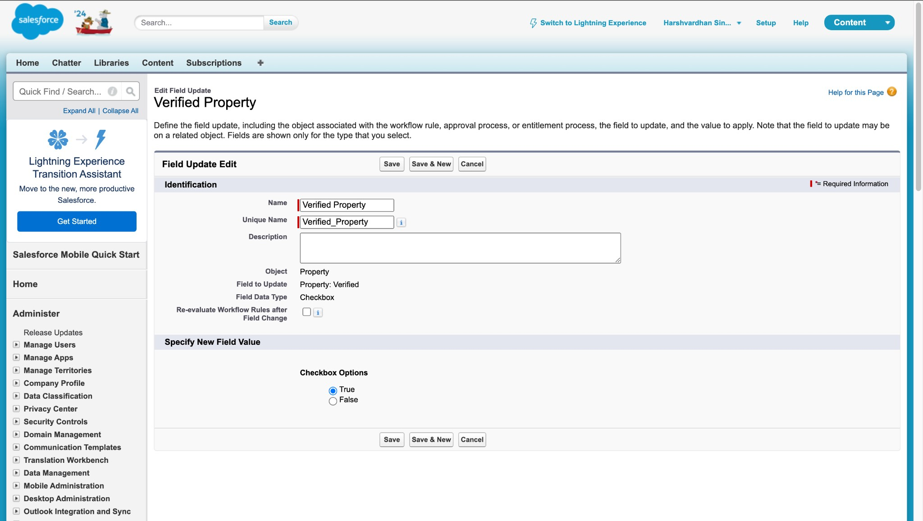

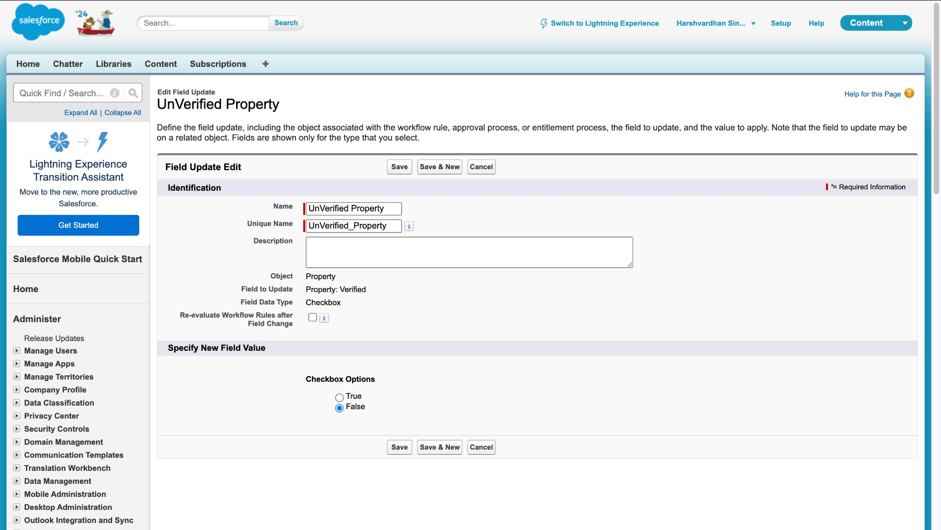

### TASK 10: Record Trigger Flow for Approval

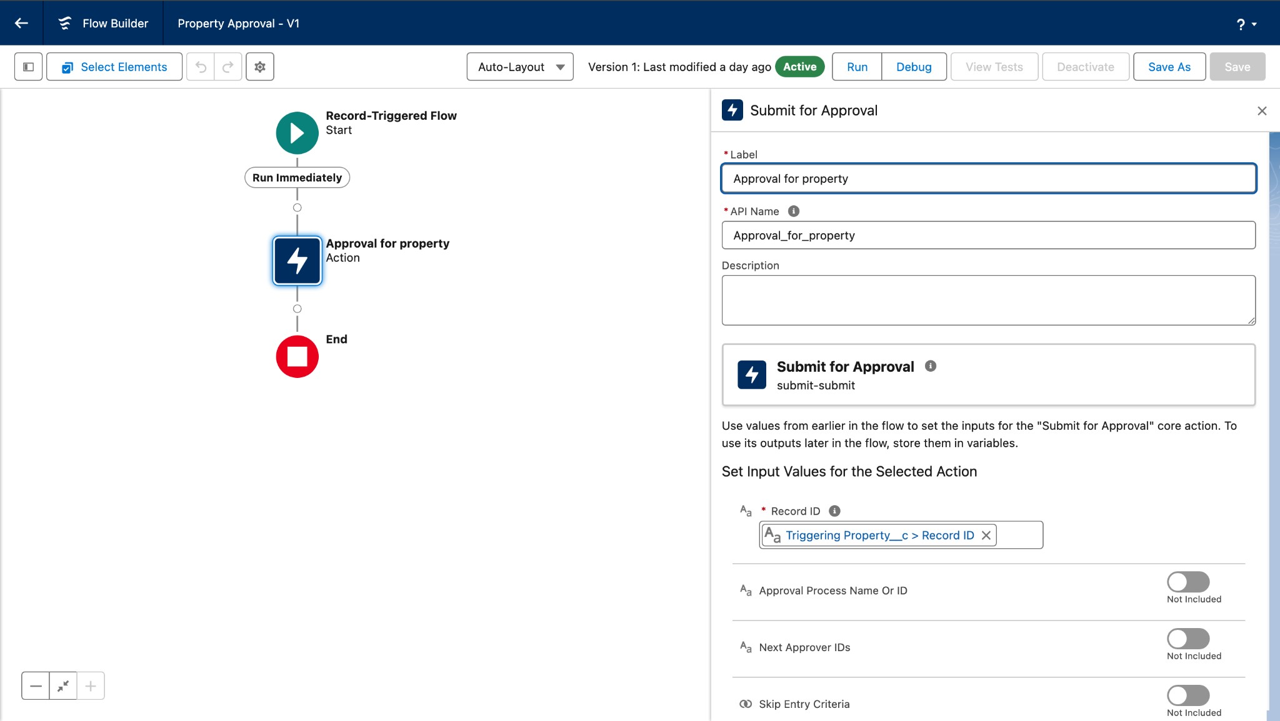Automatically submit the approval process when a property record is created.

● **Activity**:

a. Develop a Record Trigger Flow that triggers when a new property record is created and submits the record for approval.

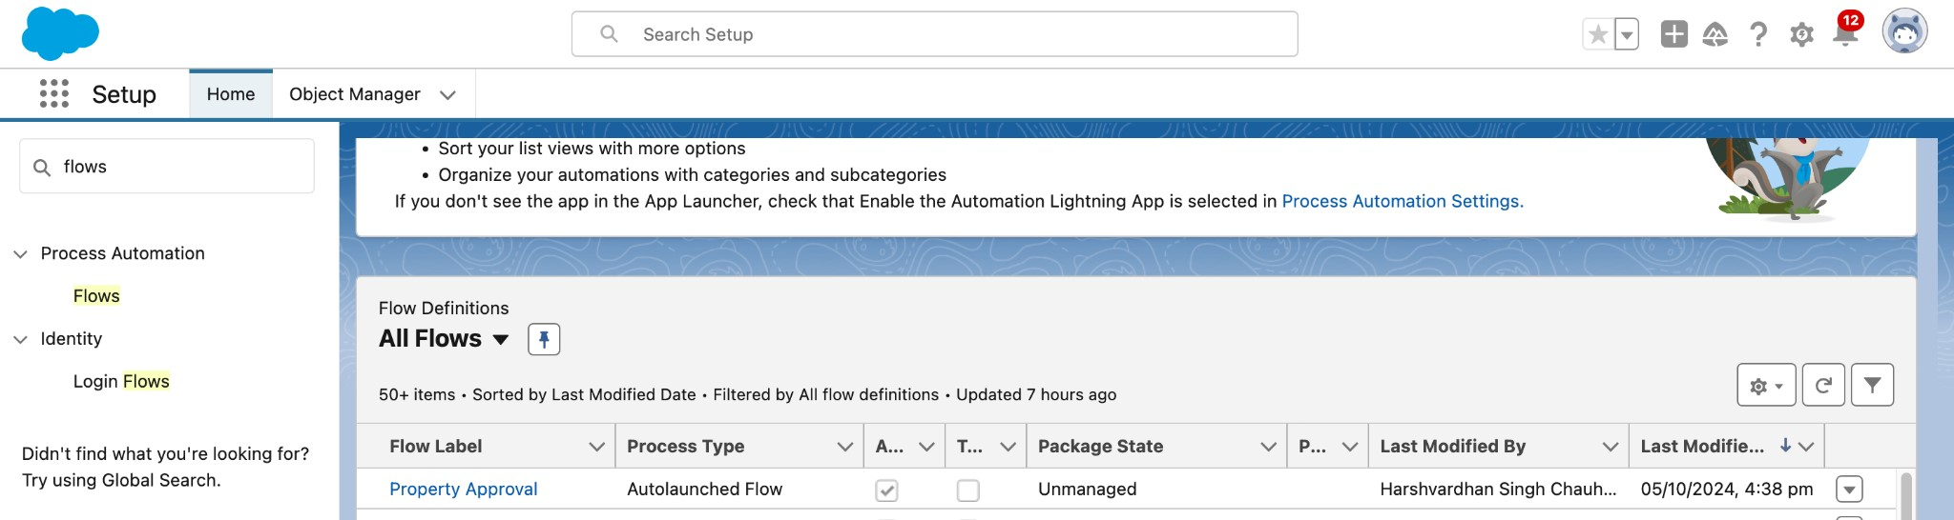

### TASK 11: Create an App Page

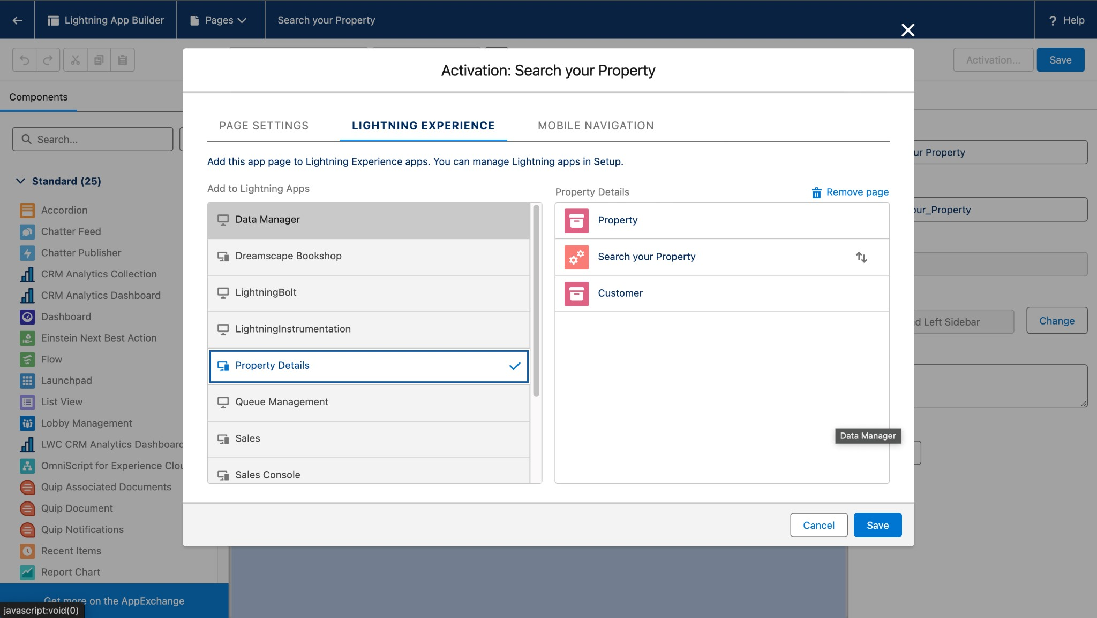Build an app page for property search functionality.

● **Activity**:

a. Create an app page labelled "Search Your Property" and add it to the Property Details app.

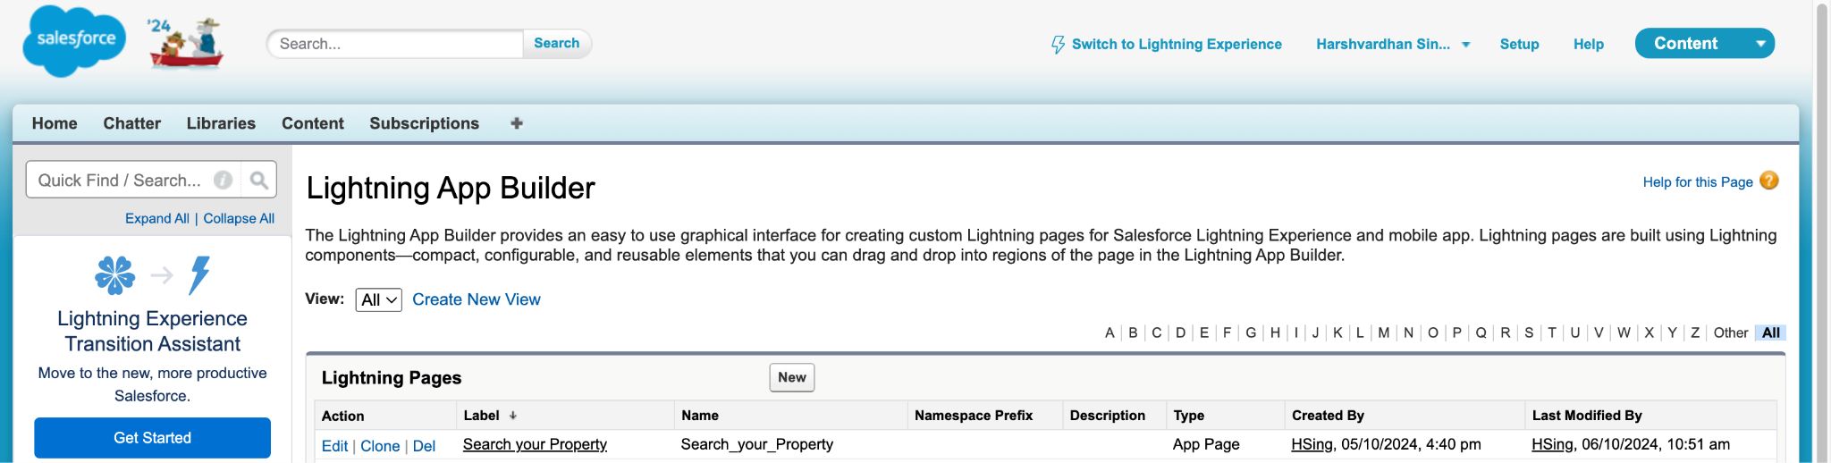

### TASK 12: Lightning Web Component (LWC)

Develop an LWC component to manage property access for verified and

unverified customers.

● **Activity**:

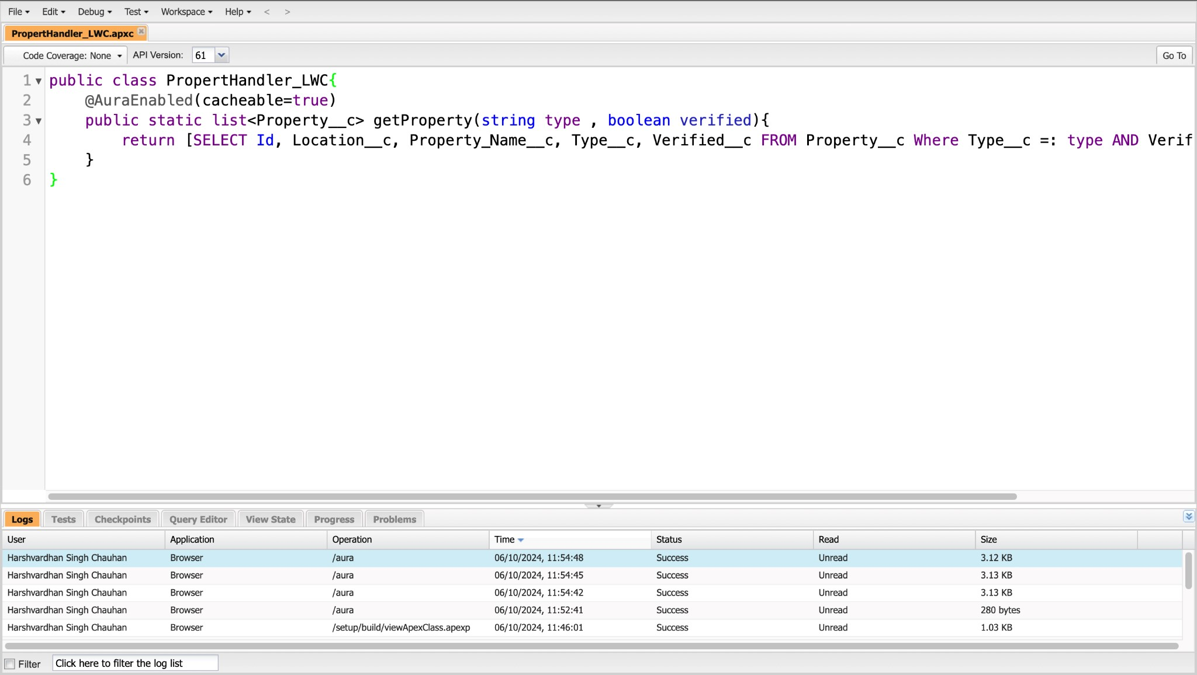a. Develop the LWC component with Apex logic to handle property visibility based on customer verification status.

- APEX CLASSES

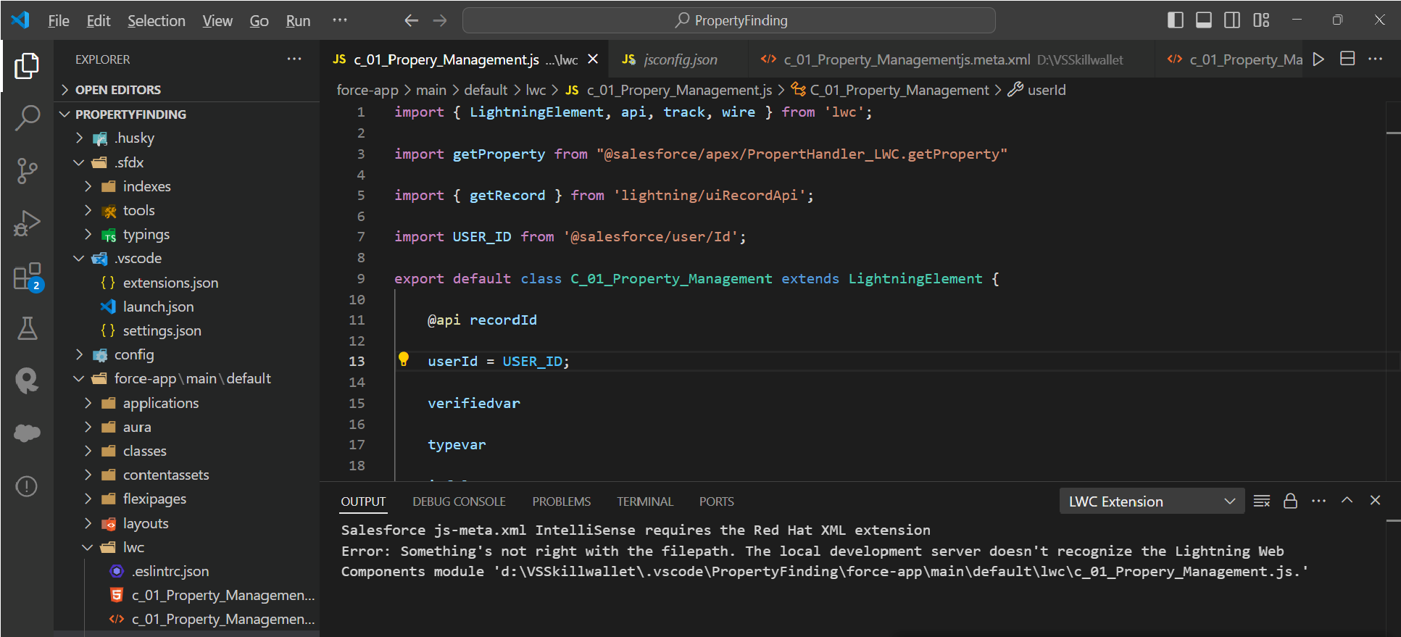

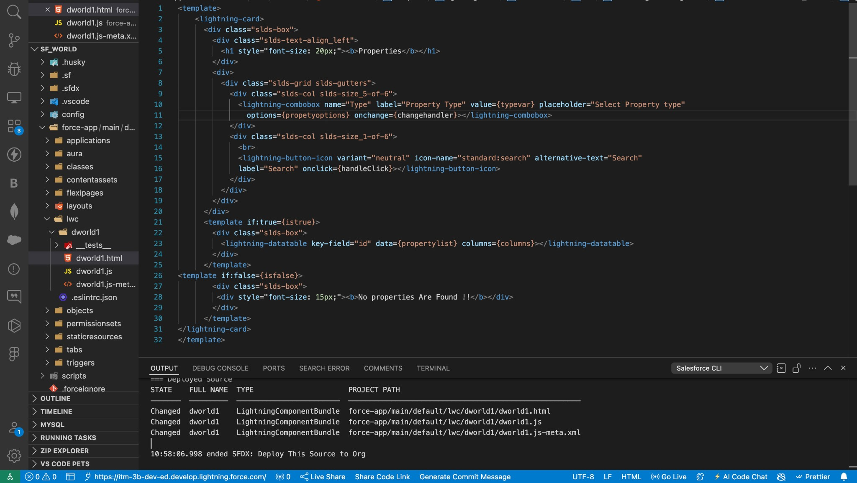

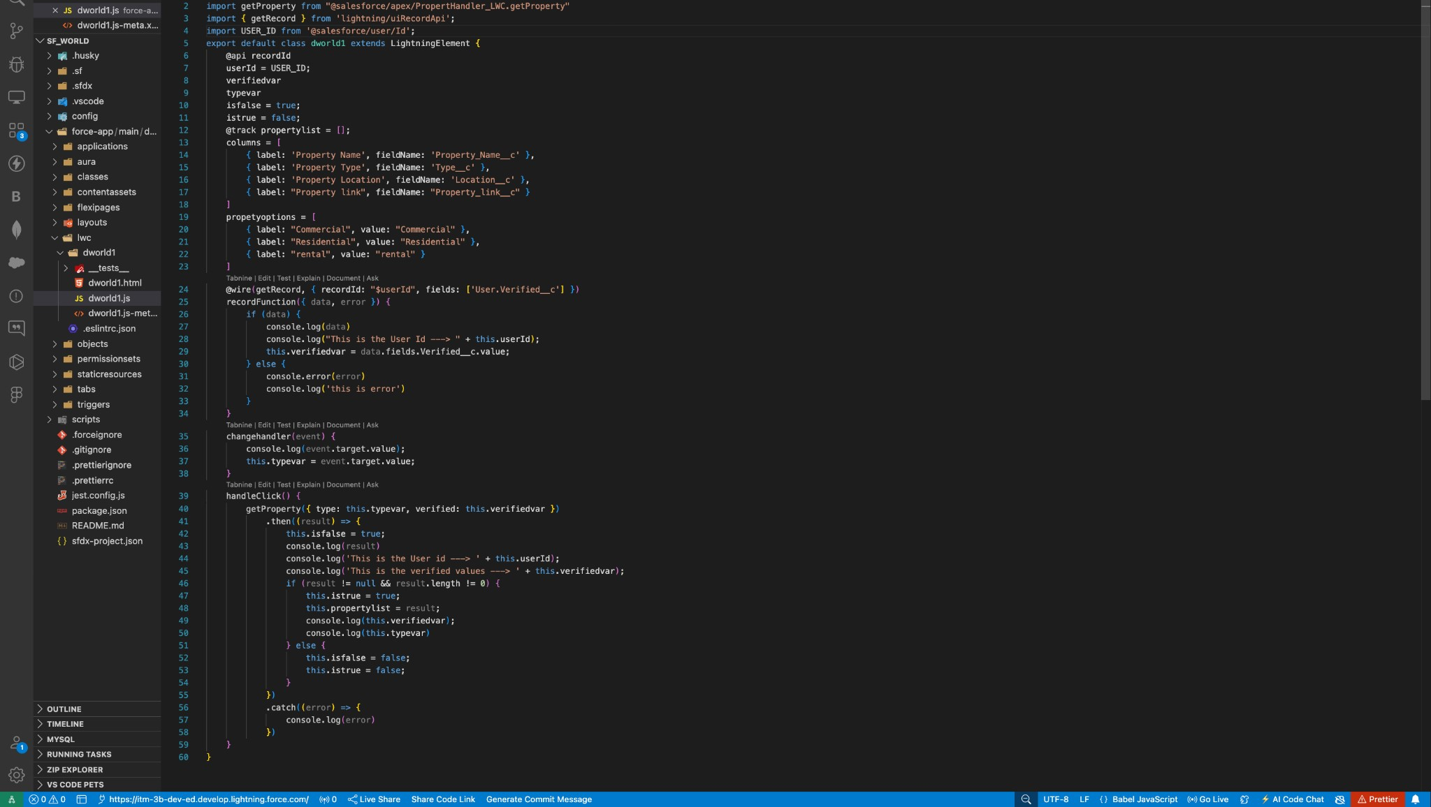

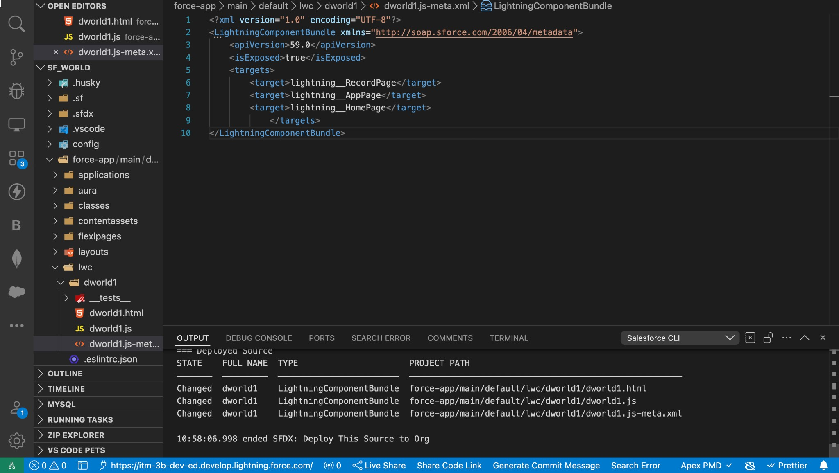

### TASK 13: Drag this Component to your App Page

**Objective**: Add the LWC component to the app page.

● **Activity**:

a. Drag and drop the LWC component onto the "Search Your Property" app page and save.

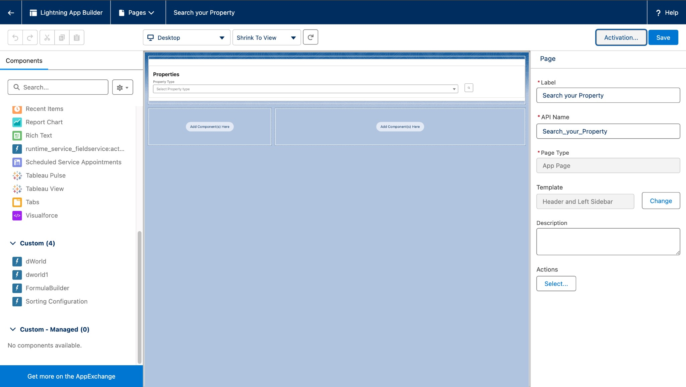

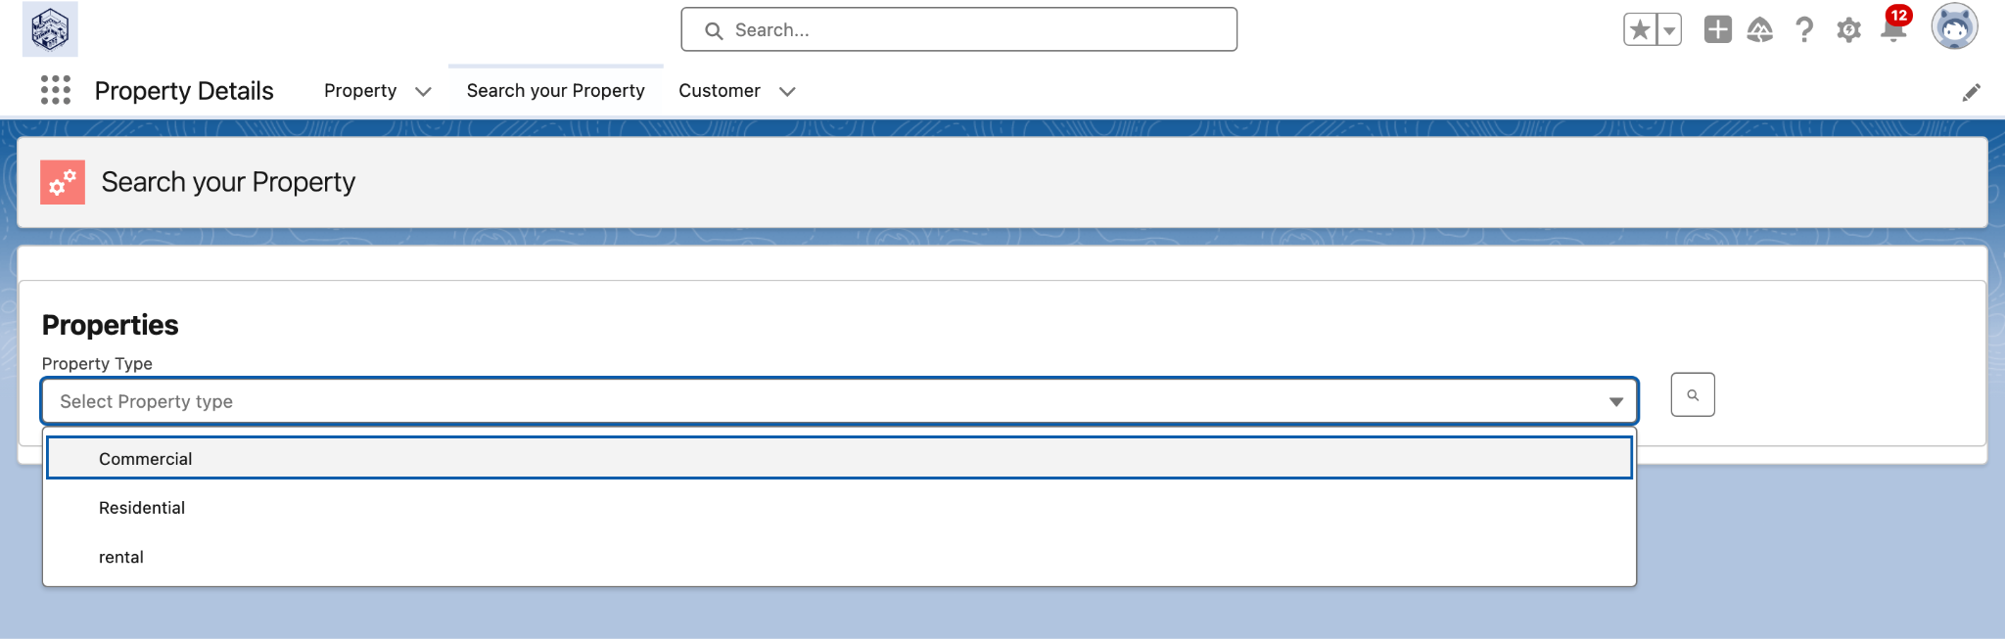

### TASK 14: Give Access of Apex Classes to Profiles

**Objective**: Set appropriate security access to Apex classes for necessary profiles.

● **Activity**:

a. Assign access to the Apex class PropertyHandler_LWC to both Manager and Customer profiles.

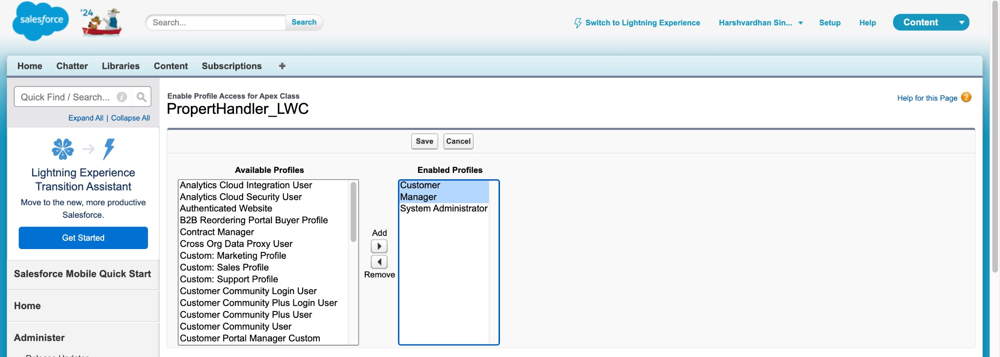

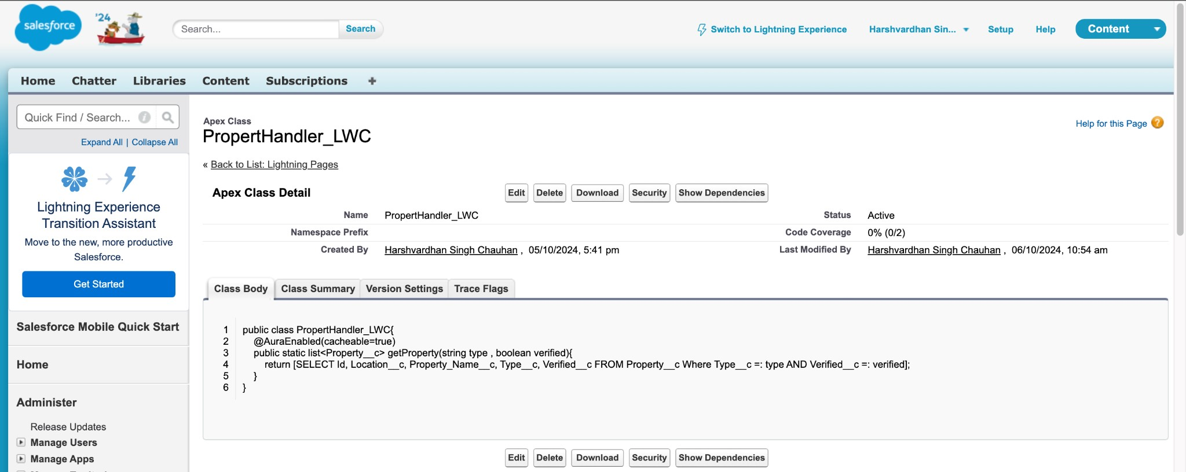

1. **TESTING AND VALIDATION:**

**Unit Testing**: Apex Classes and Triggers tested for accurate record creation and approval process.

**Tools:**

Salesforce Developer Console

Salesforce CLI (SFDX)

**User Interface Testing**: Validated LWC component display, data accuracy, and

on the App Page.

# 6. KEY SCENARIOS ADDRESSED BY SALESFORCE IN THE IMPLEMENTATION PROJECT:

* Automated client record creation from Jotform submission, eliminating manual data entry.
* Property approval process automation to ensure only verified property records are accessible.
* Property details viewing and management in a custom LWC within the Salesforce App Page, enhancing client interaction.

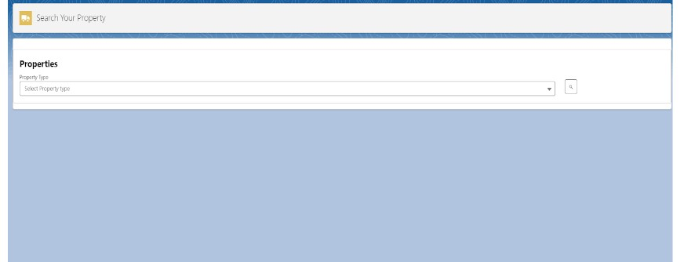

**Client Management:**

Client Onboarding:

Capture client details, such as contact information, preferences, and property requirements, through custom forms or web-to-lead integration. Use workflows to assign new clients to appropriate sales agents based on predefined criteria like location or expertise.

Duplicate Record Management:

Leverage Salesforce’s duplicate rules and matching rules to prevent duplicate client records during creation or import.

# 7. CONCLUSION:

This project successfully implemented a CRM solution for client and property management. Key achievements include automated data entry, streamlined property record approval, secure access management, and a user-friendly interface for property interaction.

The implementation of the CRM Application for handling clients and their property-related requirements has successfully addressed the project objectives, delivering a robust and scalable solution.